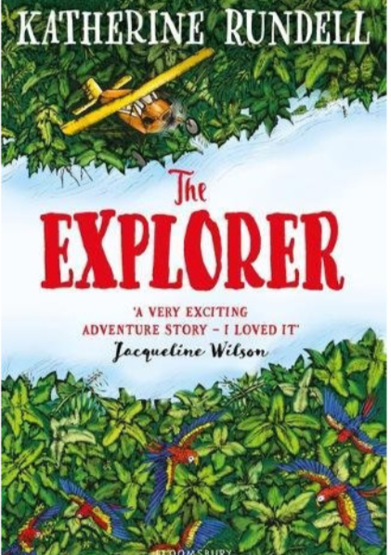
The explorer
Like a man-made magic wish, the aeroplane began to rise.
The boy sitting in the cockpit gripped his seat and held his breath as the plane climbed into the arms of the sky. Fred's jaw was set with concentration, and his fingers twitched, following the movements of the pilot beside him: joystick, throttle.

The aeroplane vibrated as it flew faster into the setting sun, following the swerve of the Amazon River below them. Fred could see the reflection of the six-seater plane, a spot of black on the vast sweep of blue, as it sped towards Manaus, the city water. He brushed his hair out of his eyes and pressed his forehead against the window.

ECOSYSTEM OF THE RAINFOREST
The Amazon is the world largest rainforest- and it has the densest concentration of life on Earth. Covering 5 million km2 across eight different countries (60% of which is in Brazil), the massive jungle is home to 10% of all the known species in the world. Glowing insects, exotic dancing birds, flesh-eating fish, tiny pygmy sloths: you name it, you will find it in the Amazon.

The Amazon’s millions of different plants and animals must complete for resources. Plants fight to break through the shady jungle canopy for sunlight; some plants have evolved to grow not in soil, but instead on top of trees as tall as skyscrapers. Competition for food sometimes results in specialised evolution, where a new species emerges with a super-specific niche. The sword-billed hummingbird’s beak is longer than its body, so it can feed from certain types of long tubular flowers that are impossible for other hummingbirds’ bills to reach.

