Reasoning

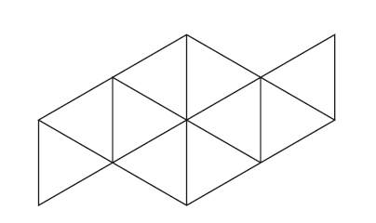Shade in $\frac{1}{5}$ of this diagram

Reasoning

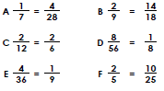
Mr Mills has written some equivalent fractions.
Find and correct any mistakes.

Problem Solving

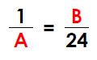

Give 2 possible values for A and B.

Problem Solving
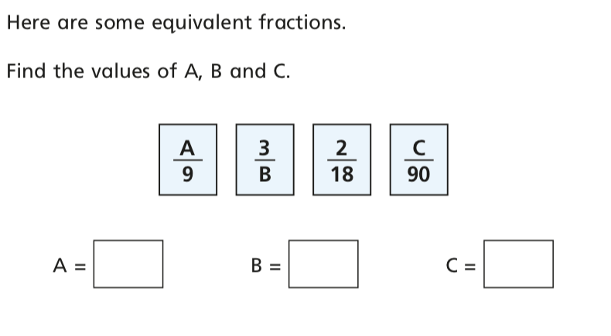

Problem Solving

