Year 5 – Week beginning 6th July

Narrative Journey- Mount Everest
After successfully conquering our challenge of climbing Everest, and describing the view from the top, this week you are going to send a postcard home to tell your loved ones all about the journey. It has been an extremely gruelling challenge so now is your chance to tell your family all about the tough conditions and hurdles you had to overcome to get to this point.
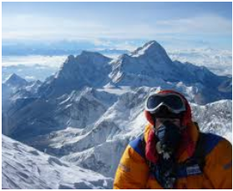
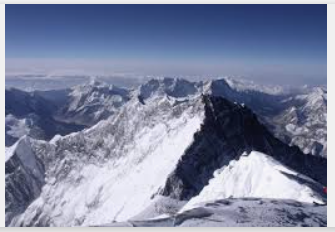

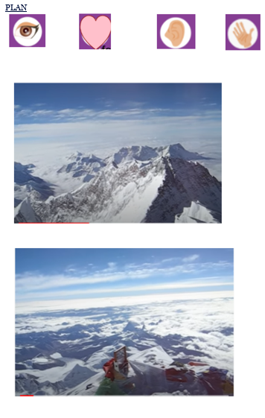
English
Your final Mount Everest English task is to write a postcard home Watch Miss Zeller’s video and use her model and success criteria to guide you. Good luck!

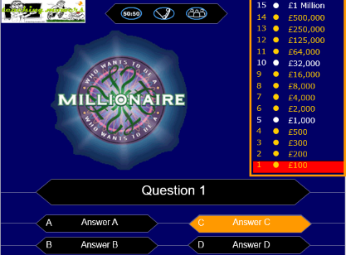

Reading
In reading we will be looking at a brand-new text called The Eye of the North by Sinead O’Hart. This would be a fantastic book for you to read over the holidays so why not try grab a copy of it.

French
This week we are going to be learning the days of the week and using them to make extended sentences.

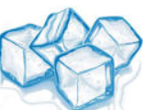
Science

Over the next few weeks, we are going to be conducting the first in a series of ice experiments. This week we are going to be learning how to fish for ice!

Maths
This week we will again continue to consolidate our arithmetic /fractions/decimal/percentages knowledge/mental maths speed and problem solving.

Additional Learning
Oak National Academy - Have a go at the science lessons:
https://www.thenational.academy/online-classroom/year-5/foundation#subjects

TTR Battle - Can you get yourself into the top 10 biggest improvers or highest scorers?
https://play.ttrockstars.com/auth

Reading for pleasure
Use Audible books to Listen to ‘Arlo Finch in the Valley of Fire’
https://stories.audible.com/pdp/B078MNZ1DW?ref=adbl_ent_anon_ds_pdp_pc_pg-1-cntr-0-31

