WALT: Write a postcard about your Mount Everest trip

EXAMPLE
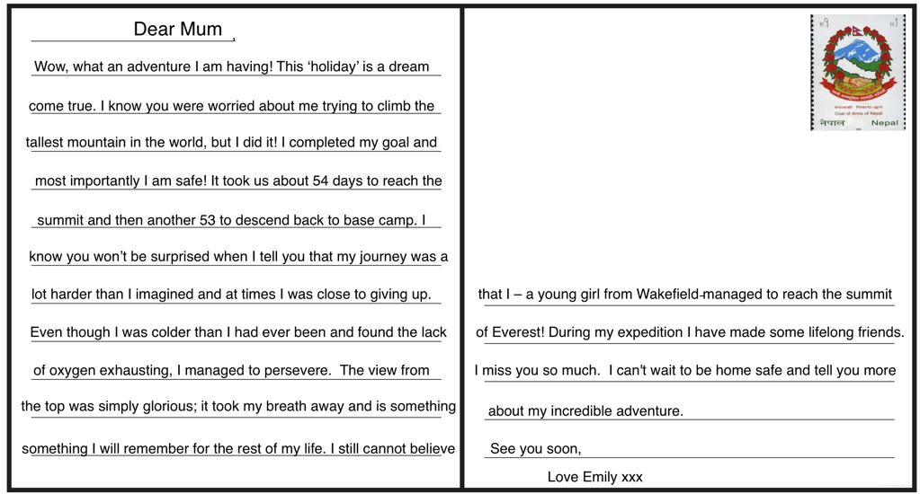

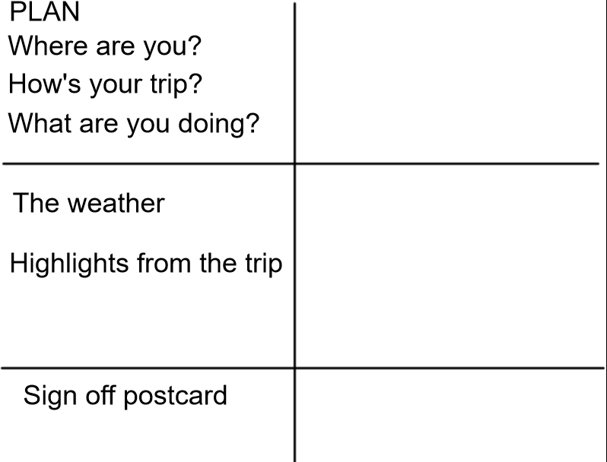

Success Criteria

The structure | Tick if complete
Dear _______,
Introduction
Weather/ Highlights of trip
Signing off postcard
Genre Features and effective techniques | Example
Fronted adverbials to help explain when/how the events take place

First person, the pronoun ‘I’ to show it is you writing it

Colloquial/chatty style like you are talking to a friend
Powerful description (adjectives) to explain the trip
Parenthesis to add extra information () -- ,,

