Description of the view on top of Mount Everest

http://www.panoramas.dk/fullscreen2/full22.html

https://www.youtube.com/watch?v=mkz7gGQe6Mk

The smoky clouds glided past me as I looked out over the horizon. Gusts of wind whistled loudly as our flags waved wildly, announcing our arrival. In the distance, I could see nothing but white peaks that looked like icing on a cake. The snowy world was mesmerising. Completely exhausted, I bent down to touch the soft flakes, the freezing temperature burnt my hands. Snuggling into my thick coat it hit me, we had done it. What an achievement! I could barely speak. I let the moment sink in. From the top of Mount Everest, I felt immense pride. I made it; I was on top of the world.

PLAN
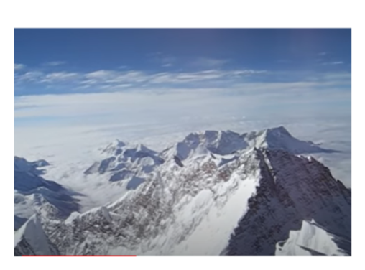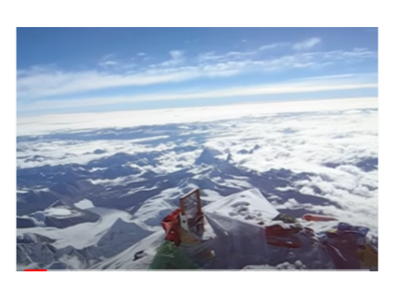
Fronted Adverbials
In the distance,
Along the horizon,
Far away,
Above the clouds,
Everywhere I looked,
To the left,
Almost unbelievably
Out of breath,
Completely exhausted,
Trembling with excitement,
Totally overwhelmed,
Never in my life,

Success Criteria
The structure | Tick if complete
What can you see?
How do you feel about finally reaching the summit?
Genre Features and effective techniques | Example
Detailed description (powerful adjectives) to illustrate the incredible sight at the summit
Fronted adverbials to vary sentence starters
Short sentences to create excitement
Use of senses (sight, touch, noise and feeling)
Figurative language (Similes, metaphors or personification) to bring the description to life

