Year 6 Geography

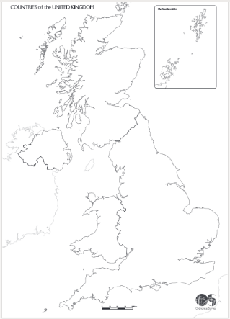
Lesson 1
- Research the United Kingdom, Great Britain and the British Isles. Which countries make up each? Can you explain the difference?
- Using the blank map of the United Kingdom, can you locate and label the countries and their capitals?
- Locate and label where you live and 5 cities which interest you.
- Label the following on your map:
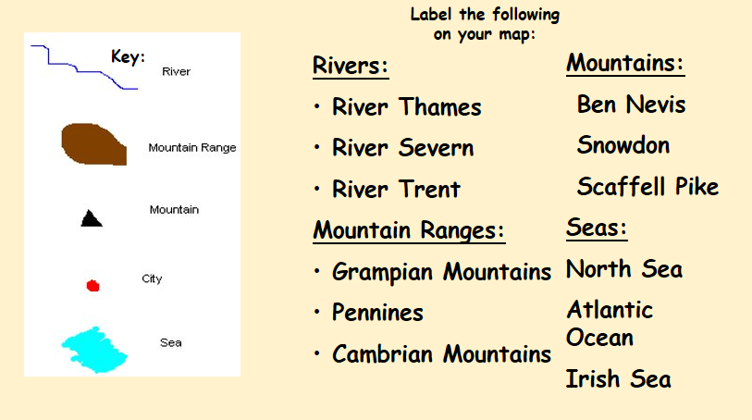

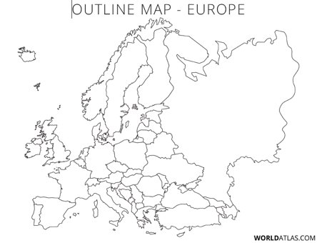
Lesson 2
- Research the countries in Europe using an atlas or the Internet and then label them on the map.
- Research 6 major mountain ranges and 6 major rivers in Europe and label these on the map.
- Use your map and research to answer the following questions:
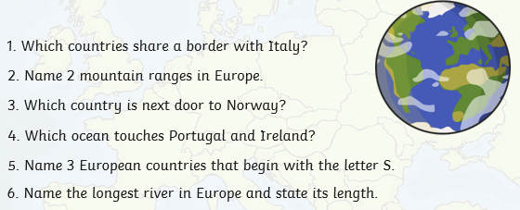

Lesson 3
- Watch the following video on European countries, capital cities and flags. https://www.youtube.com/watch?v=7QFIp83AXMI
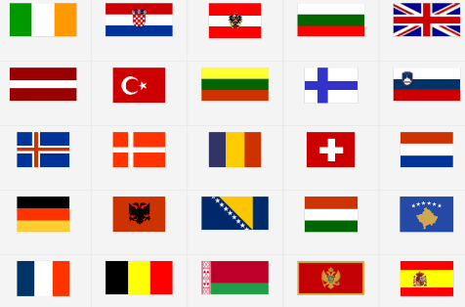
- Match the countries, capitals and flags. Use the video, an atlas or laptops/Ipads to help you. You can either work on the sheet (only a selection are included on the sheet) or draw and colour your own. You don’t have to do all the countries and flags. Choose at least 10 which interest you. Challenge yourself and don’t do the ones you already know!
- Try an online quiz such as: https://online.seterra.com/en/qz/5002

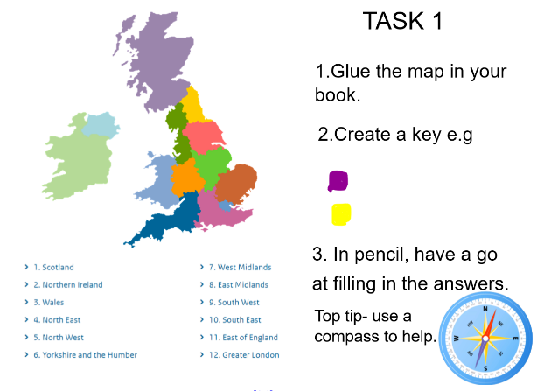
Lesson 4
- Discuss what regions are. Discuss what regions are in the UK. Explore where the regions may be located using your knowledge of a compass.
- Discuss what human and physical features mean in geography.

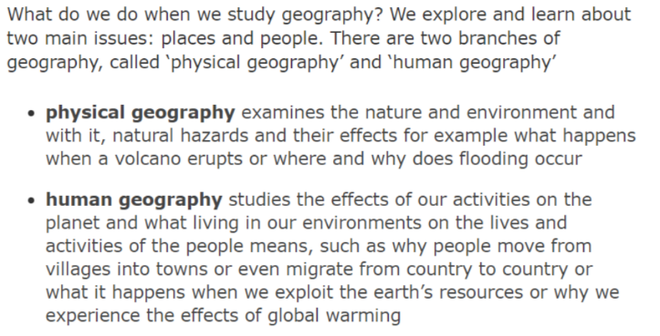
Create a double page spread explaining the human and physical features of Texas (this links to our class book Holes). Consider climate, population, wildlife, language, location on a map, landscape and many more!
Include information from your research, pictures and drawings. Use the document on the website for ideas. Have fun!

