WALT: Solve multiplication and division word problems

Warm up
- 34 x 43 = 2. 65 x 76 = 3. 345 x 36 =

4. 456 4 = 5. 785 8 = 6. 876 9=

Word problems
- Alisha went on a shopping spree and bought 12 pairs of shows. Each pair cost £18. How much did she spend?

- Sam played 252 notes on the piano in 6 minutes. How many notes did he play in a minute?

- If Riley eats 23 biscuits a day, how many does he eat over 66 days?

- Mr Stanley wants to replace the school’s footballs. Each football costs £16 and he wants to order 40. How much will they cost?

- Dave had saved £3588 in 6 months. How much had he saved each month?

- Emma buys a jar full of 126 sweets. She wants to get enough sweets to last her all year, so she buys another 4 jars. How many sweets are there in all 5 jars?

- Mr Gifford goes to watch the football 17 times in a month. How many times does he watch the football in a year?

- Steve buys 23 stamps at 45p each. How much does he spend in total? Give your answer in pounds.

- Angel has drawn 245 beautiful pictures in each day in August. How many pictures did she draw in total?

- There are 11g of rice in one portion. How many portions are there in a 3kg bag of rice?

Multiplication Challenge
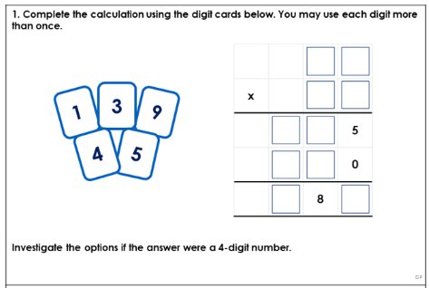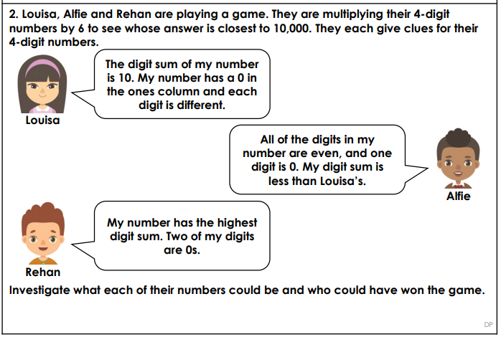

Division Challenge
