Existing Mount Everest tour companies
https://www.alpineascents.com/climbs/mount-everest/

https://www.adventureconsultants.com/expeditions/seven-summits/everest/

https://www.adventurepeaks.com/shop/climb-everest/

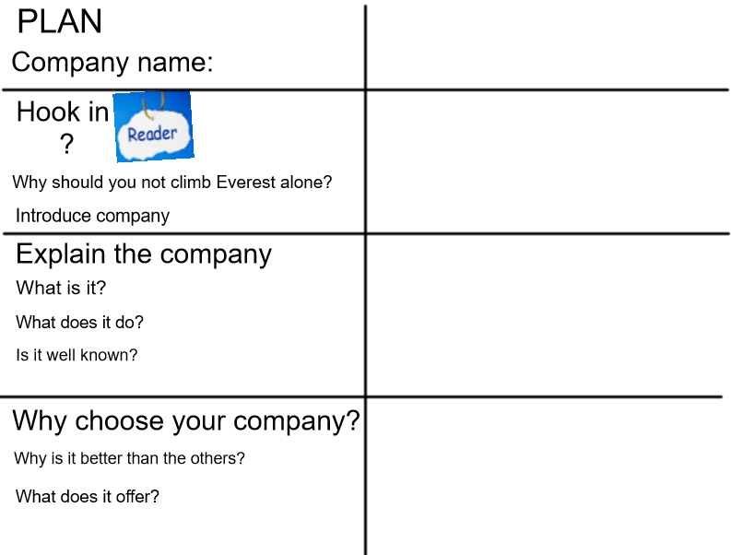

Example Advert for company
Everest together.
Are you dreaming of climbing the highest mountain in the world? If you are considering giving this once in a lifetime opportunity a shot — then you need to go with the best possible service provider. The summit can be treacherous and scary, so do not climb it alone. Instead, join the newest, world-class expedition team ‘Everest together’ and let us assist you on your journey to success.
Everest Together is a team of highly skilled climbers who will guide you in your ascent to the world-famous Mount Everest summit. At ‘Everest Together’, we endeavor to provide a quality climb, whilst ensuring that safety is ABSOLUTELY paramount. We have a growing reputation around the Himalayas and indeed the world for providing the best Everest expeditions. We are, to put it simply, the best in our business.
For starters, we have a team of high-quality leaders and international climbers, who have great experience and expertise of the wild wilderness of Everest. All of ‘Everest Together’ expeditions are carefully prepared so your safety and success is guaranteed. We investigate quality climbs, select optimum routes and supply top provisions. We aim to provide you with the best experience and memories that will be with you for a lifetime. We plan every climb to meet your needs and will work endlessly to support YOU.
Contact details
Website: Everesttogether.com
Email:everesttogether@climbing.co.uk

Success Criteria
The structure | Tick if complete
Company name
P1- Hook the reader
P2- Explain the company
P3-Why choose your company?
Genre Features and effective techniques | Example
Rhetorical question to make the reader think deeper

Detailed description (powerful adjectives) to persuade reader.
Alliteration to make it memorable
Words in bold or capitalised to grab the reader’s attention

Pronoun ‘YOU’ to make the text personal

