WALT: Write a survival guide ‘How to climb Mount Everest’

Watch this video to find all your information on how to climb Mount Everest-

https://www.youtube.com/watch?v=Veou4qXS0Lo

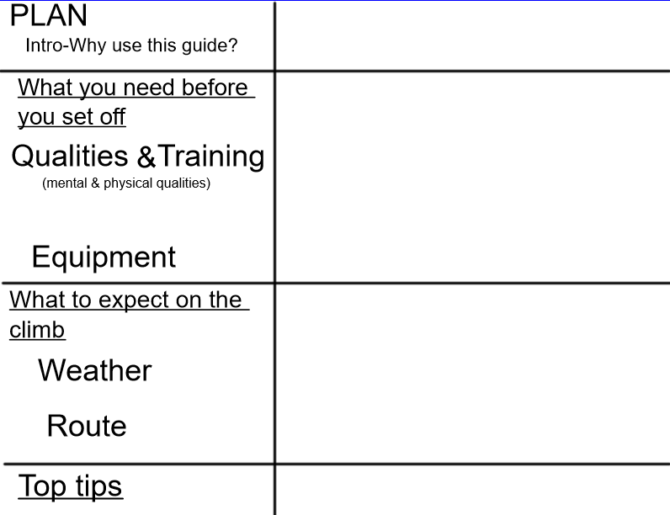

Success Criteria

The structure | Tick if complete
Why use this guide?
What you need before you set off
What to expect on the climb
Top tips
Genre Features and effective techniques | Example
Subheadings to help organise the information.
Bullet points to list key points.
Pictures to explain the information.
Time conjunctions (first, next & afterwards) to show the order.
Modal verbs to show what is recommended (must, should, could).

