Year 5 – Week beginning 8th June

Narrative Journey- Mount Everest
Now you are a Mount Everest expert you must help others achieve their goal of reaching the summit. This week is focused on developing a world class expedition company. Are you ready for the responsibility? Are you up for the challenge?
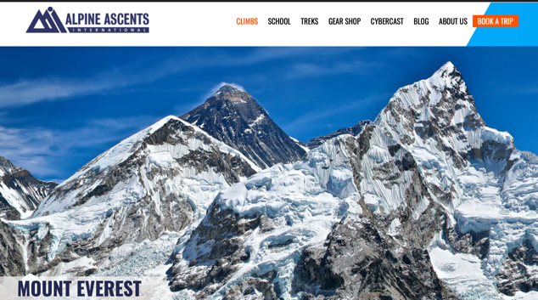
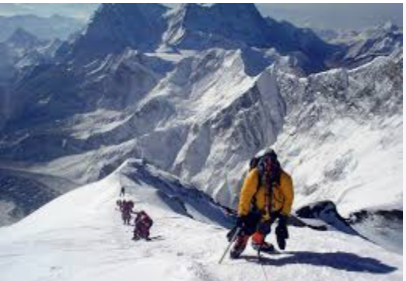

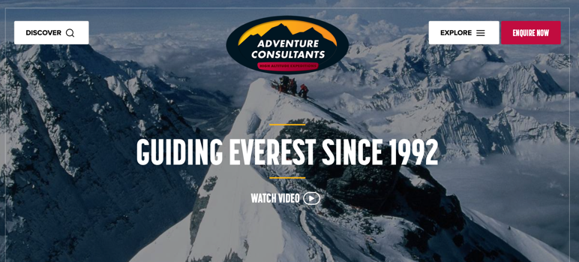

English
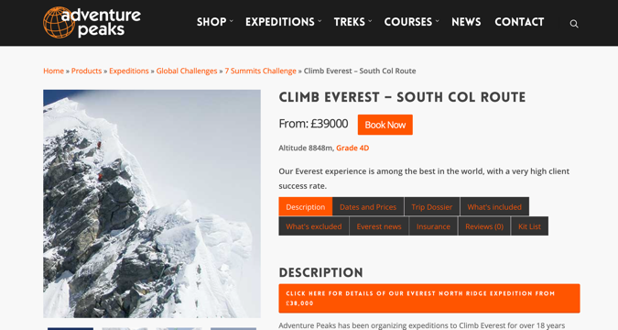
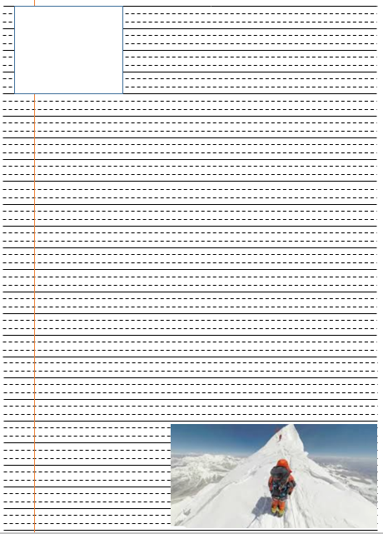
Your task this week involves creating an advertisement for your new company that leads expeditions up Mount Everest. It is important to complete your market research and review current Mount Everest tour companies such as, Alpine Ascents, Adventure Consultants and Adventure Peak. You must come up with a catchy name for your company and your advertisement must explain why the climbers should choose YOUR company to complete their Mount Everest trek with. Watch Miss Zeller’s video and use her modal and success criteria to guide you. Good luck!
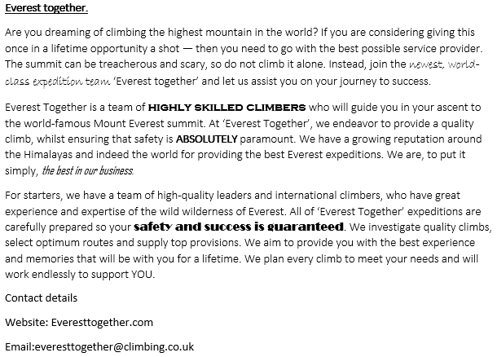
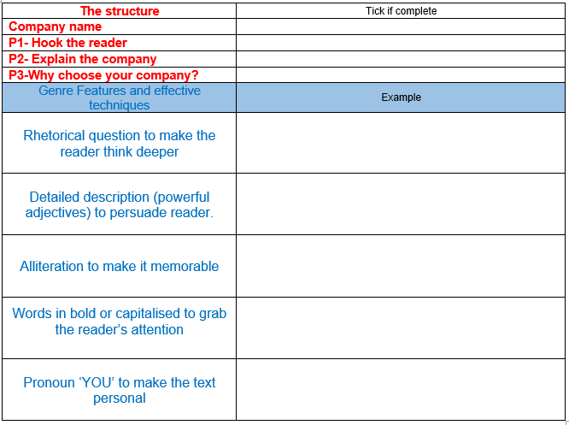
Art
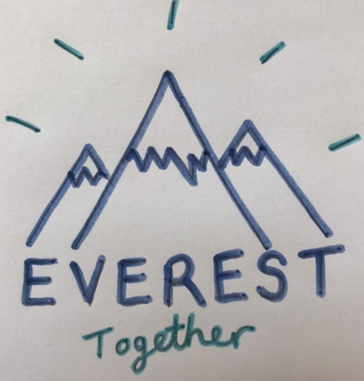
This week we are learning to design a logo for our expedition company. We will be considering the important elements of logo design.

Geography
In Geography this week will be learning more about Mountains. On the resource sheet is a link to a BBC bitesize website full of information, videos and quizzes. This link will also allow you to complete a world map locating the mountain ranges.
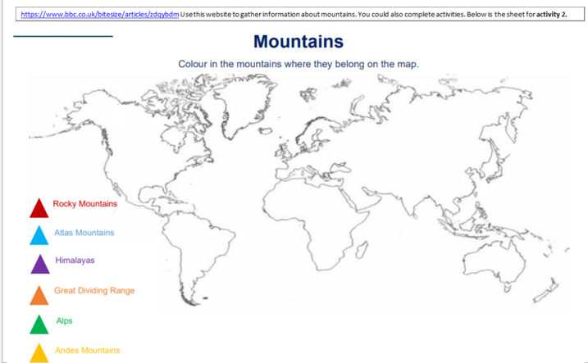
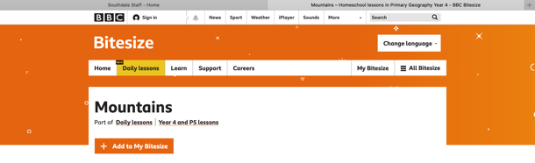
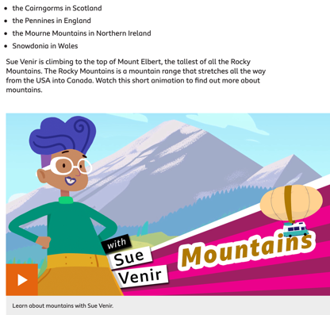

Reading
In reading we will be exploring a non-fiction text, the intro to the ‘Everest 1953: The epic story of the first ascent’.

French
In French we are going to learn about the capital city of France, Paris. You will then use your knowledge, and some clues, to answer questions about important places in France. You also have the chance to build a pocket-sized Paris!
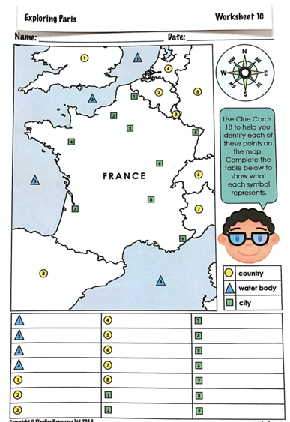

Maths
Monday
WALT: calculate the area of rectangles

Tuesday
WALT: read and plot coordinates in the first quarter

Wednesday
WALT: reflect shapes

Thursday
WALT: reflect shapes with coordinates

Friday
WALT: translate shapes

Additional Learning
Oak National Academy - Have a go at the science lessons:
https://www.thenational.academy/online-classroom/year-5/foundation#subjects

TTR Battle - Can you get yourself into the top 10 biggest improvers or highest scorers?
https://play.ttrockstars.com/auth

Reading for pleasure
Use Audible books to Listen to ‘Arlo Finch in the Valley of Fire’
https://stories.audible.com/pdp/B078MNZ1DW?ref=adbl_ent_anon_ds_pdp_pc_pg-1-cntr-0-31

Sports Day
Look out for Mr Biltcliffe’s sports videos in preparation for a virtual Sport’s Day

