Year 5 – Week beginning 22nd June

Narrative Journey- Mount Everest
You have begun your first expedition with your new tour company, and you have successfully reached Base Camp 4, but your journey is not over. The only thing that lies between you and the famous Mount Everest summit is… DEATH ZONE. Are you mentally and physically strong enough to take on DEATH ZONE? Giving up is not an option; It’s now or never!
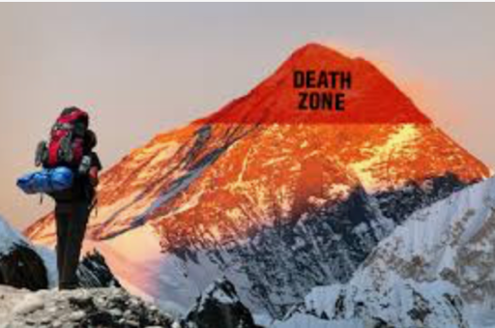
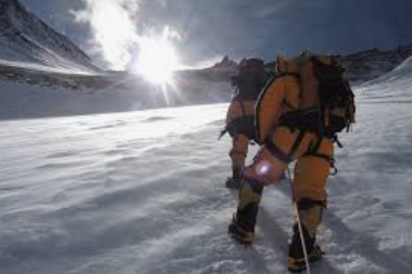

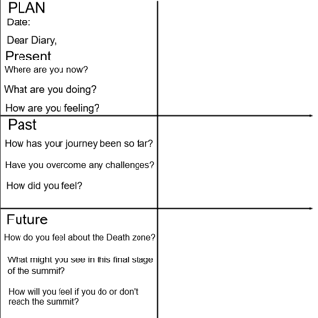
English
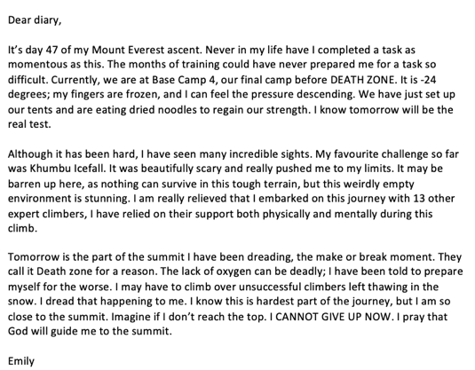
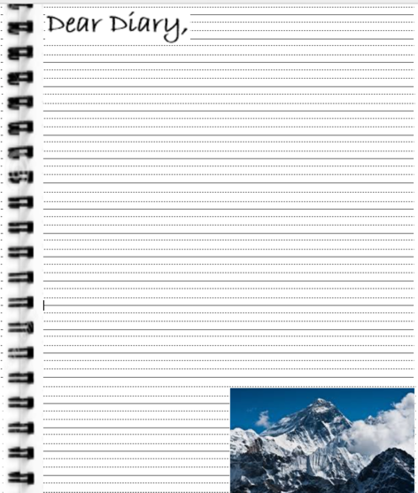
Your task this week is to write a diary entry about your experience so far climbing Mount Everest. Watch Miss Zeller’s video and use her modal and success criteria to guide you. Good luck!

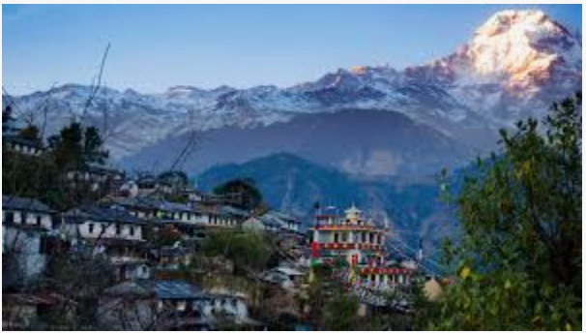
Geography
In Geography you will be researching about Nepal or China, the two countries Mount Everest borders. Use the website given to create a fact file about your country.

Reading
In reading we will be exploring Winter Olympics.

French

In French you will be learning some cookery instructions and ingredients vocabulary before having a go at making crêpes!
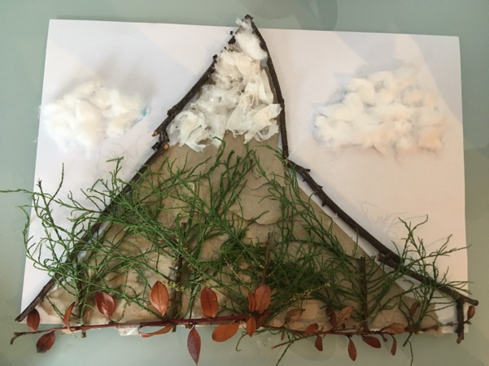
Art

In Art you must gather materials to make Mountain landscape collage.

Maths
Consolidation work and data

Additional Learning
Oak National Academy - Have a go at the science lessons:
https://www.thenational.academy/online-classroom/year-5/foundation#subjects

TTR Battle - Can you get yourself into the top 10 biggest improvers or highest scorers?
https://play.ttrockstars.com/auth

Reading for pleasure
Use Audible books to Listen to ‘Arlo Finch in the Valley of Fire’
https://stories.audible.com/pdp/B078MNZ1DW?ref=adbl_ent_anon_ds_pdp_pc_pg-1-cntr-0-31

