Year 5 – Week beginning 15th June

Narrative Journey- Mount Everest
The time to begin your climb is drawing closer, but are you ready? Before you set off you must be prepared for whatever obstacles or dangers you may encounter on your ascent. Do you know the route inside out? Are you equipped to conquer the tallest mountain in the world? Only time will tell…

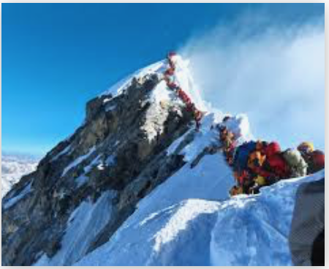
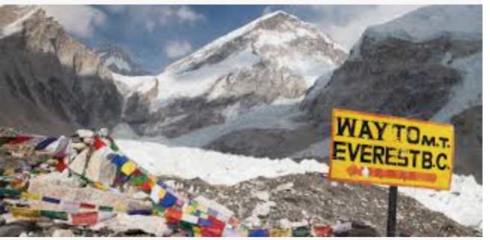

English
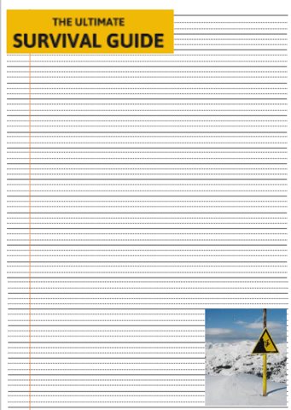
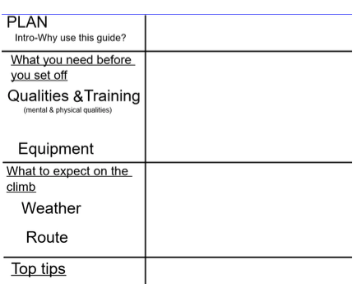
Your task this week is to write a survival guide explaining how to climb Mount Everest. Watch Miss Zeller’s video and use her model and success criteria to guide you. Remember you guide could be the difference between life and death. Good luck!

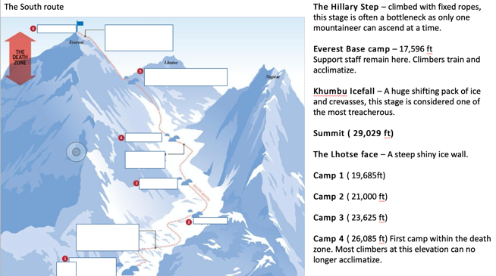
Geography
In Geography you will be investigating the south col route that Hillary followed when conquering Everest.
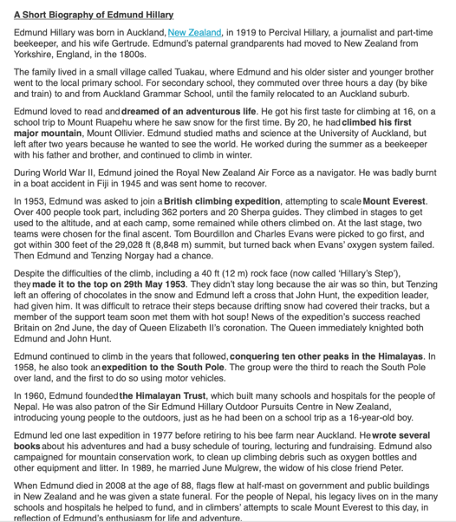

Reading
In reading we will be exploring a biography of Edmund Hilary.

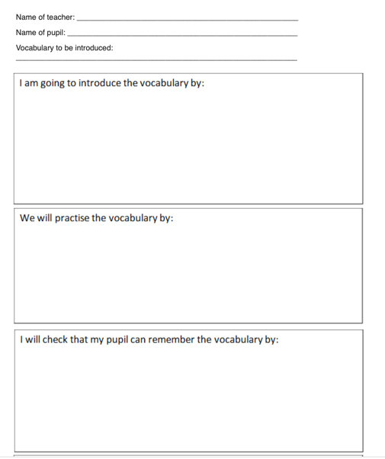
French

In French you will be practising your vocabulary by planning and teaching your own French lesson!

Maths
Monday
WALT: consolidate our arithmetic knowledge

Tuesday
WALT: solve word problems involving addition and subtraction

Wednesday
WALT: solve word problems involving multiplication and division

Thursday
WALT: solve 2 step word problems involving the 4 operations

Friday
WALT: consolidate our arithmetic knowledge

Additional Learning
Oak National Academy - Have a go at the science lessons:
https://www.thenational.academy/online-classroom/year-5/foundation#subjects

TTR Battle - Can you get yourself into the top 10 biggest improvers or highest scorers?
https://play.ttrockstars.com/auth

Reading for pleasure
Use Audible books to Listen to ‘Arlo Finch in the Valley of Fire’
https://stories.audible.com/pdp/B078MNZ1DW?ref=adbl_ent_anon_ds_pdp_pc_pg-1-cntr-0-31

