WALT: Write a diary entry about your ascent up Mount Everest

If you want to read
https://www.aucklandmuseum.com/discover/stories/blog/2013/hillarys-everest-diary-entry-for-29-may

Dear diary,

It’s day 47 of my Mount Everest ascent. Never in my life have I completed a task as momentous as this. The months of training could have never prepared me for a task so difficult. Currently, we are at Base Camp 4, our final camp before DEATH ZONE. It is -24 degrees; my fingers are frozen, and I can feel the pressure descending. We have just set up our tents and are eating dried noodles to regain our strength. I know tomorrow will be the real test.

Although it has been hard, I have seen many incredible sights. My favourite challenge so far was Khumbu Icefall. It was beautifully scary and really pushed me to my limits. It may be barren up here, as nothing can survive in this tough terrain, but this weirdly empty environment is stunning. I am really relieved that I embarked on this journey with 13 other expert climbers, I have relied on their support both physically and mentally during this climb.

Tomorrow is the part of the summit I have been dreading, the make or break moment. They call it Death zone for a reason. The lack of oxygen can be deadly; I have been told to prepare myself for the worse. I may have to climb over unsuccessful climbers left thawing in the snow. I dread that happening to me. I know this is hardest part of the journey, but I am so close to the summit. Imagine if I don’t reach the top. I CANNOT GIVE UP NOW. I pray that God will guide me to the summit.

Emily

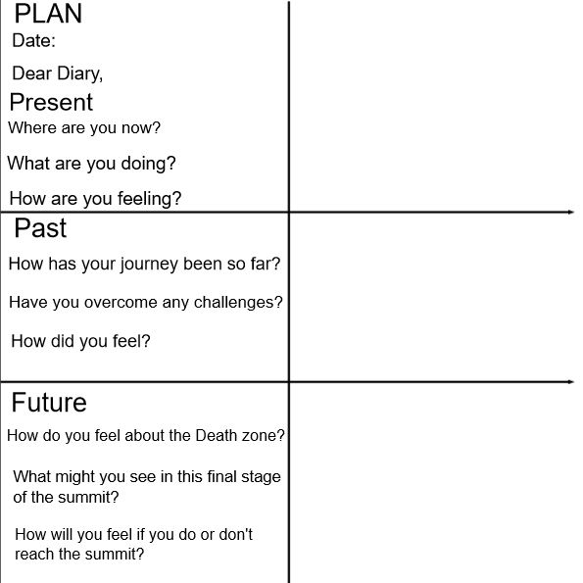

Success Criteria

The structure | Tick if complete
Date & Dear Diary,
Present: Where are you now?
Past: What has happened so far on your journey?
Future: How do you feel about the final stage of your summit?
Genre Features and effective techniques | Example
Fronted adverbials to help explain when/how the events take place

First person, the pronoun ‘I’ to show it is you writing it

Colloquial/chatty style like you are talking to a friend
Self-reflection to show how you feel, opinions and worries

