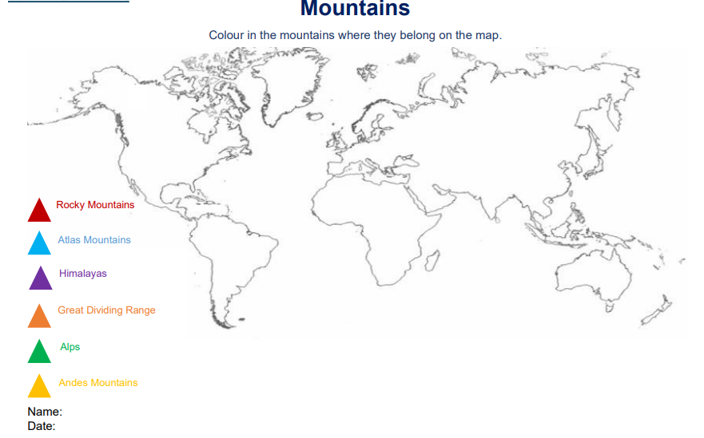

<https://www.bbc.co.uk/bitesize/articles/zdqybdm> Use this website to gather information about mountains. You could also complete activities. Below is the sheet for **activity 2.**