Year 6 – week beginning 18th May 2020

Narrative Journey
For the past couple of weeks, you have continued to amaze us with your findings about the Titanic. Now is your chance to find out any last bits of information that you would like to discover, by researching any aspects of the Titanic that we have mentioned over this half term. Why not try out the Titanic maths challenge on our website page?

English
In English this week, we are focusing on poetry! Read through our favourite Titanic poems and choose the one that you would like to focus on. Once you have decided if you are going to perform a verse, a few verses or the whole poem, you need to start learning it off by heart. When you have learnt it, you need to practise reciting it with expression, intonation and volume (the YouTube video explains these terms). It is then time to perform it! Give it your all and perform the verse or poem to your family. If you would like to record it and send it to us via email or twitter, then of course we would love to see it! Check out the YouTube video for an extra challenge as well.

Reading
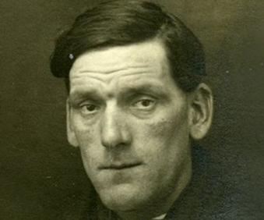
In reading this week, we are going to analyse and respond to a poem about a hapless worker aboard the Titanic, following our usual reading activities. Here is the link to the article about stoker John Priest: Titanic’s unsinkable stoker. http://bbc.co.uk/news/uk-northern-ireland-17543632

Maths
Monday - WALT: calculate perimeter
Tuesday - WALT: calculate the area of rectangles
Wednesday - WALT: calculate the area of triangles
Thursday - WALT: calculate the area of parallelograms
Friday - WALT: calculate volume

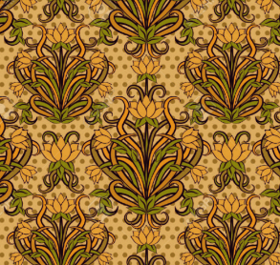
Art
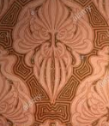
In art this week, we are going to be diving into the interior of the Titanic, with focus on the patterns they used in the 1900’s. See the YouTube video for more information on what Art Nouveau is, and how you can re-create your own design in your very own first-class cabin!

Additional Learning
- TTRS – keep practising your times tables!
- Well-being challenge 1 – relax like a cat
- Well-being challenge 2 – self-portrait to email to r.mallas@southdale.wakefield.sch.uk
- Be sure to check out your French activity with Mrs Gibbons – you are going to be talking about pets!

