Year 6 – week beginning 11th May 2020

Narrative Journey
You have done fantastically well researching the Titanic so this week we would like you to spend this time focusing on your writing in English. Use what you have found out these last few weeks to really add historical facts and details to your writing. If you are really eager to carry on with your research, why not delve into information about the lifeboats – this will help to make your writing in English even more realistic.

English
This week we are writing a first person recount of the Titanic sinking. This means carefully planning/drafting and editing our writing. Our reading work and work from the past few weeks will really help with this.

Reading
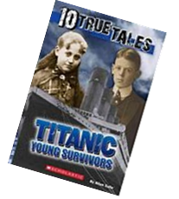
Our reading lessons this week will be based on an extract from the book, ‘Titanic Young Survivors’. We will start by using book talk techniques to write our thoughts, questions and wonders based on Eva Hart’s story. We will explore the effective vocabulary used and unpick the definitions carefully. On Thursday we will be checking our understanding of the text by answering some tricky VIPERS questions. Reading this text will also help us to explore the thoughts and feelings of the passengers and support us with writing our description of the tragedy in English.

Maths
Monday - WALT: read and interpret graphs accurately.
Tuesday - WALT: read and interpret tables accurately.
Wednesday - WALT: plot points on line graphs.
Thursday - WALT: read and interpret pie charts.
Friday - WALT: interpret pie charts involving percentages.

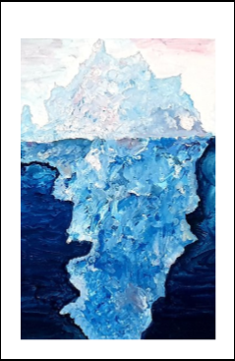
Art
In art this week, using what we have learnt so far, you are tasked with the challenge of creating your final piece. Watch the YouTube video for lots of ideas that you could do at home. We cannot wait to see what you produce!

Additional Learning
TTR – keep practicing your times tables!
Computing - have a go at Mrs Mohebi’s task from last week.
French with Mrs Gibbons

