Year 6 – week beginning 4th May 2020

Narrative Journey
This week, look at a different aspect of the Titanic that you researched last week. You could research:
- Details about the different class of passengers
- What happened to the boat in the years after the sinking
- Who the main crew were
- Food aboard the Titanic (Libby produced an excellent video of this last week)
- Any other aspect that interests you…

For the presentation of your work this week, see below for English.

English
In English you have the task of independently carrying on some research on the Titanic and producing your own information text about it. Remember to use subheadings to break up your text.

Reading
In our reading lessons this week we will be finding out about two third-class passengers aboard the Titanic. As usual we will be exploring it through book talk (thoughts, questions and wonders), picking out and delving deeper into some interesting vocab and finishing the week with VIPERS questions. Let’s really push ourselves this week year 6 and add detail and evidence to our responses!

Maths
Monday - WALT: revise ratio
Tuesday - WALT: solve ratio problems
Wednesday - WALT: solve ratio problems
Thursday - WALT: solve proportion problems

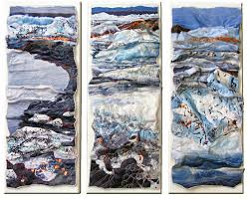
Art
In art this week, we are continuing with our sequence of art lessons, with the second part of the project being an artist study. You need to find out who Sandra Meech is, what inspires her to produce the art that she does, and consider how her work links to our ideas. See the video on YouTube for more details!

Additional Learning
TTR – keep practicing your times tables!

