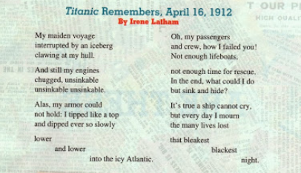
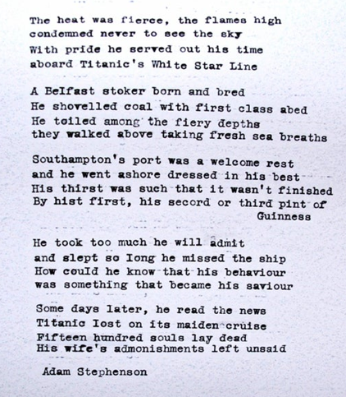

Titanic

By Valerie Dohren

Fair maiden of the ocean deep
This mighty vessel lost to sleep
A jewel `neath a moonless sky
`Twas fate that she so soon would die
Against the ice her doom was sealed
Just ten percent of it revealed
As close against its buried side
With grace and dignity to glide
The greater part was hid below
For so it be with frozen snow -
A jagg`ed fortress `neath the sea
A dark, unseen catastrophe
Her belly slashed, then set to die,
(Upon the ocean bed to lie) -
Into her hull the ocean gushed
People and objects swirled and crushed
But no-one listened to her cries
Nor even to her calls did rise
And none acknowledged all her flares
Nor sought to answer all her prayers
Two hours and forty minutes passed
With all her charges holding fast
Just twenty lifeboats, not yet filled,
(And fifteen hundred hearts were stilled)
Water seeping into her heart
Tearing her very soul apart
Invincible of White Star Line
She lurched, she groaned, with severed spine
O`er time a saviour ship arrived
To aid the ones who had survived
To take them thus into her care
A ship of safety anchored there
But in the darkness of the night
In ice-cold waters void of light
Bounced scattered souls upon the waves
Descending to their watery graves
Then all the while, when hope was gone,
In calm repose the band played on -
`Nearer My God To Thee, ` they think,
As, with grace, she started to sink
One hundred years her memory
Still lingers `neath the raging sea
Within the hearts of all bereft
Of those whose lives have long since left
They said that sink she never could
But oh, dear God, she surely would!
Invincible of White Star Line
She lurched, she groaned, with severed spine
And though one century has passed
Lost souls in memories are cast
Their eyes as stars in heaven dwell
Reflected in the ocean`s swell
With tales of life and secrets kept
Of those who loved and those who wept
Your stories you will never tell
Farewell, my friends, farewell, farewell...
The sun upon the shimm`ring sea
Will ever your companion be.

Titanic (The Unsinkable Ship)
by Kim Robin Edwards

What people believed in 1912.
Was a myth in the truth, placed on a shelf.
Was the unthinkable, unsinkable..
The forty six thousand gross tons of steal.
Would never kneel or break its bow.
The ship could never sink or rust.
Was rumour going round, we all could trust.
The crowd showed up to celebrate.
As the ship was Christened to show its fate.
But The White Star Line was cruising fine.
When it hit a berg, under a darkened sky.
There it lie, with many to cry.
At the bottom of the sea she'll die.
They said the Titanic could never sink.
Their opinion a myth, now she's on the brink.
With forty six thousand gross tons of steal.
The voyagers finished their final meal.
To the bottom of the ocean they went.
A many to cry, while she made her descent.
The Titanic was a ship in trouble.
But now a myth, and a pile of rubble.
At the bottom's where she made her grave.
A sigh of relief, for the lives they saved.
To the rescue, and on the double.
Titanic was a ship in trouble..
Her maiden voyage, now turn the page.
Thousand of people, in a fit of rage.
The news it read that we all should mourn.
The Titanic's passengers, their lives were torn.
A myth of truth placed in the news.
The unsinkable ship. Would never lose.

