Example
INCREDIBLE OFFER OF A LIFE TIME!
Unique and fabulous persons wanted
Did you ever dream of becoming a star?
Would you like a thousand eyes staring in awe at your talent?
Well look no further P.T BARNUM, who runs the most incredible show on the planet, is hiring. HE WANTS YOU!
Barnum’s show is like no other. His acts are extraordinary. He gives each of his entertainers his valuable knowledge and expertise so that they can reach their full potential.
Whether your talent is mind boggling, artistic or simply stunning, you must showcase it to the world – please do not hide your talent away!
This chance is for YOU; you will be superb, special and sensational! This really is a once in a lifetime opportunity. It would be silly to not apply.
Not only does this job give you the chance to perform to thousands a night and be adored by many, but there are countless other perks of the job. If successful you will have:
- Comfortable accommodation
- Remarkable food
- A generous wage
AND
Become part of Barnum’s big FAMILY
Don’t miss out; don’t live with regret! Simply apply and let you dreams come true. Show your true talents! This is your chance to change your life forever.
Auditions take place 1pm, 14th May, at P.T Barnum’s Grand Museum.

PLAN
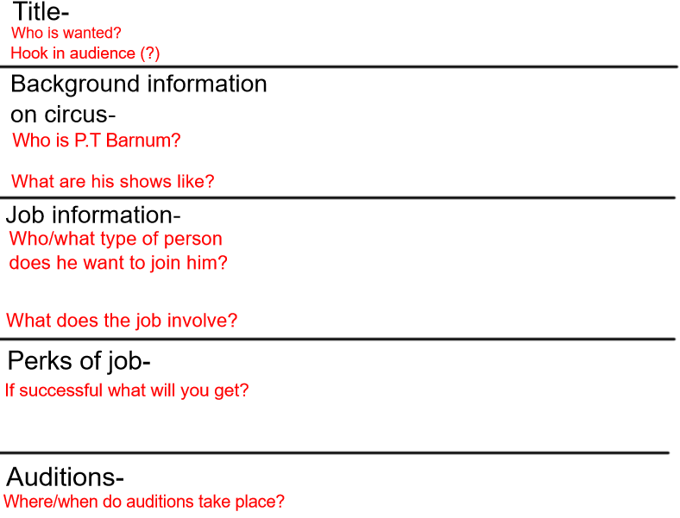

Success criteria
The structure | Tick if complete
Titles to hook the reader
Background information about the circus
Information about the job
Perks of the job
Information about the auditions
Genre Features and effective techniques | Example
Words in bold or capitalised to grab the reader’s attention

Rhetorical question to make the reader think deeper
Alliteration to make it memorable
Detailed description (powerful adjectives) to persuade reader
Pronoun ‘YOU’ to make the text personal

