Motivational Poem example

Let No One Steal Your Dreams

Let no one steal your dream
Let no one tear apart
The burning of ambition
That fires the drive inside your heart

Let no one steal your dreams
Let no one tell you that you can’t
Let no one hold you back
As I believe you are star

Let no one steal your dreams
Follow your heart
Follow your goal
You are special
When you follow your dreams
You will feel truly whole

Set your sights and keep them fixed
Set your sights on high
Let no one steal your dreams
Your only limit is the sky

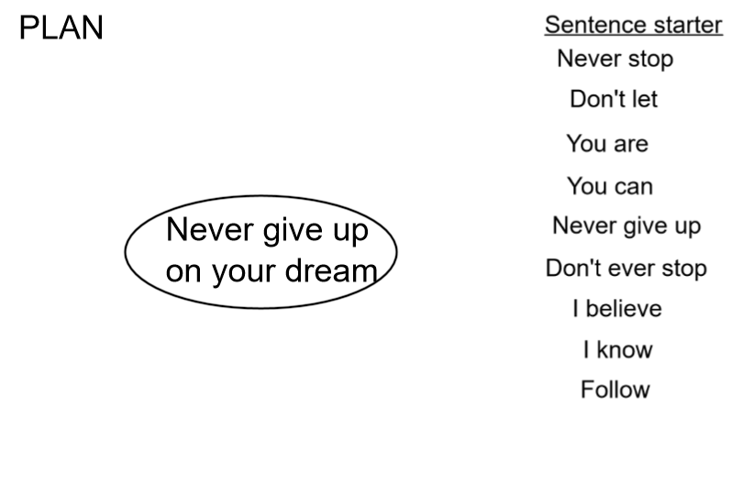

Success Criteria

The structure | Tick if complete
Stanza 1
Stanza 2
Stanza 3
Stanza 4
Genre Features and effective techniques | Example
Repetition to make it memorable

Rhyming couplets to help the poem flow

Adjectives to make the reader feel good
Figurative language (metaphor and similes) to help create a picture in the reader’s head

