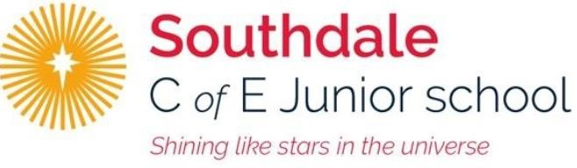
Year 5 – Week beginning 4th May

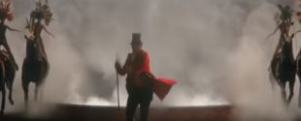
Narrative Journey
We have been absolutely overwhelmed with how intrigued and enthused you have all been about our new narrative. You’re writing a job advert this week in English and researching some of BT Barnum’s circus performers in History.

English
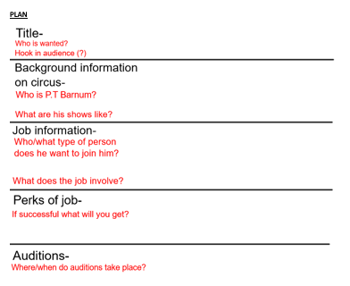
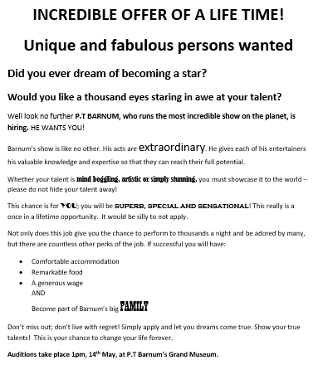
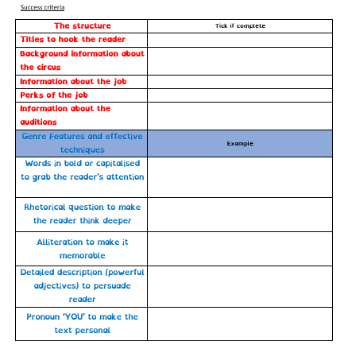
Your task this week is to write a job advertisement persuading people to join B.T Barnum’s circus. This is because he dreams of having the greatest show on earth so he needs to recruit the best performers. Watch Miss Zeller’s video and use her modal and success criteria to guide you. Good luck!

Art/Reading
This week we will be looking at the song “This is me” and creating artwork using lyrics from the song.

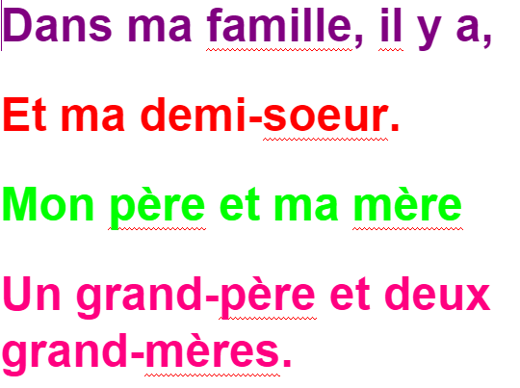
French
This week we are learning how to have dialogue, introducing our family members.

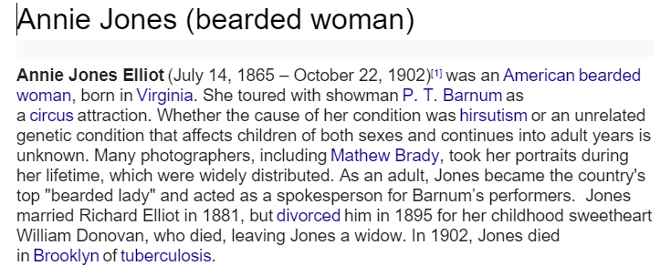
History
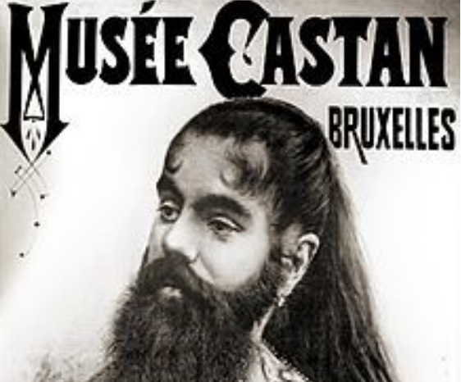
Incredibly the ‘Greatest Showman’ is based on real events that happened in History. P.T Barnum was real and so were many of his performers. This week we have given you information on 3 of his performers (Annie Jones, Tom Thumb & Fedor Jeftichew). Choose one and using the sheets we have given you, gather information on your individual.

Maths
Monday -WALT: understand thousandths as decimals.
Tuesday - WALT: round decimals.
Wednesday - WALT: order and compare decimals
Thursday – WALT: understand percentages
Friday – WALT: percentages and fractions and decimals.

Additional Learning
Oak National Academy - Have a go at the science lessons:
https://www.thenational.academy/online-classroom/year-5/foundation#subjects

TTR Battle - The year group boys vs girls battle will run all week. Can you get yourself into the top 10 biggest improvers or highest scorers?
https://play.ttrockstars.com/auth

Reading for Pleasure - Mr Mills will continue to read ‘You are Awesome’ by Matthew Syed each day.

