Year 5 – Week beginning 1st June

Narrative Journey- Mount Everest
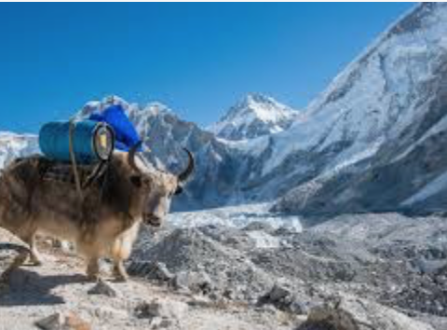
Have you got what it takes to be part of a brand new, exciting company? Are you able to undertake effective research that will persuade other to join your expedition? Have you got the skills and mindset needed to climb treacherous mountains? Do you want to be part of the best Everest expedition team ever? Pack your equipment; get yourself to base camp and let the journey begin. This narrative really will take you to the very top of the world!
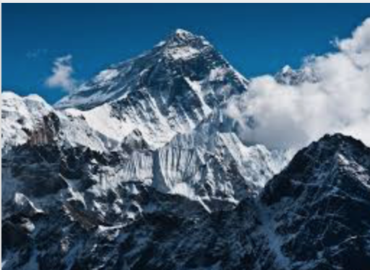

English/History/Geography
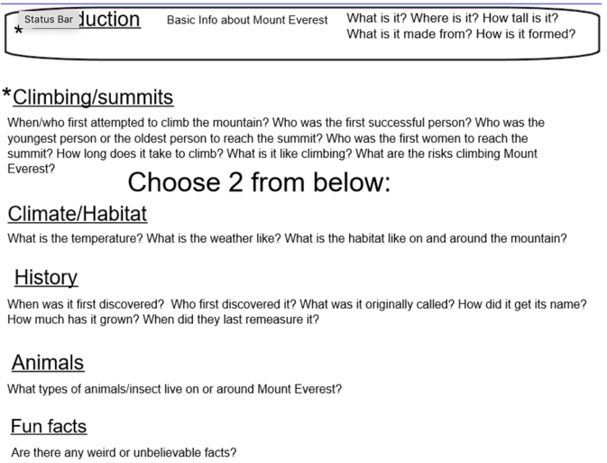
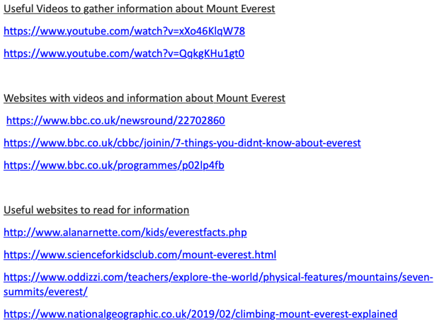
Your task this week involves researching about Mount Everest and then writing an information text. Your information text must include an introduction paragraph, a paragraph about climbers and then the other paragraphs you can choose from History, animals, climate or fun facts. Miss Zeller has given a list of helpful videos and websites for you to gather your Mount Everest research. Watch Miss Zeller’s video and use her success criteria to guide you. Good luck!

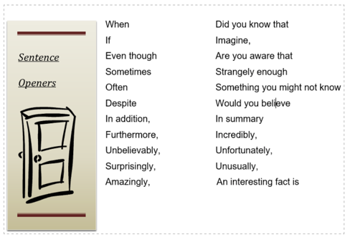

Art
In Art we are creating an Andy Warhol inspired series of Everest images. We will be concentrating on our use of colour combinations.
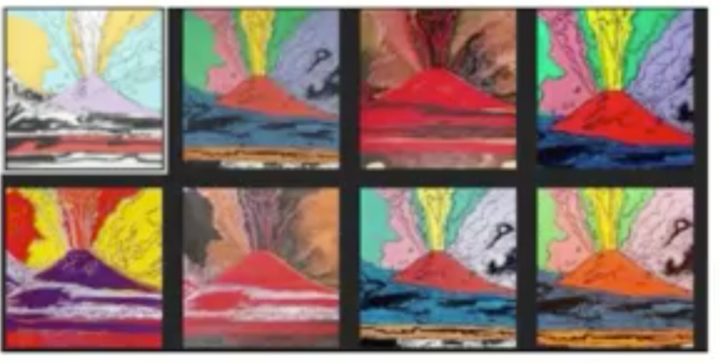
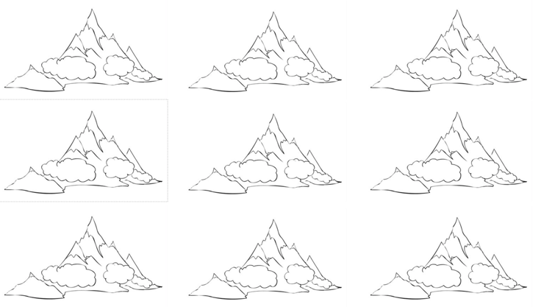

French
In French we will be playing a game of ‘Who wants to be a Millionaire?’ to revise the vocabulary covered so far this year.

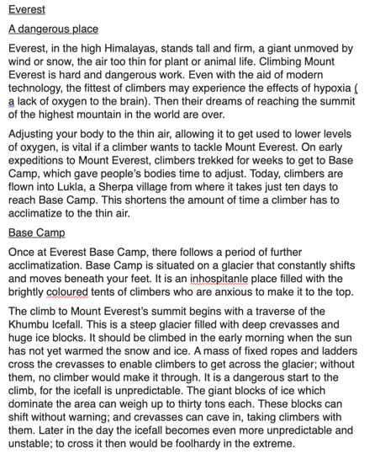
Reading
In reading we will be exploring a non-fiction text about Mount Everest.

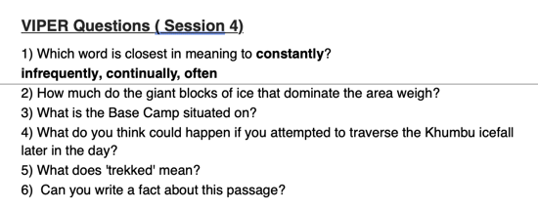

Maths
Monday
WALT: multiply 4-digits by 2-digits
Tuesday
WALT: divide with remainders
Wednesday
WALT: Multiply decimals by 10, 100 and 1,000
Thursday
WALT: divide decimals by 10, 100 and 1,000
Friday
WALT: calculate perimeter

Additional Learning
Oak National Academy - Have a go at the science lessons:
https://www.thenational.academy/online-classroom/year-5/foundation#subjects

TTR Battle - Can you get yourself into the top 10 biggest improvers or highest scorers?
https://play.ttrockstars.com/auth

Reading for pleasure
Use Audible books to Listen to ‘Arlo Finch in the Valley of Fire’
https://stories.audible.com/pdp/B078MNZ1DW?ref=adbl_ent_anon_ds_pdp_pc_pg-1-cntr-0-31

