Year 5 – Week beginning 18th May

Narrative Journey
Can you believe it is our final week of Greatest Showman? We have been super impressed with all your hard work! Well done!

English
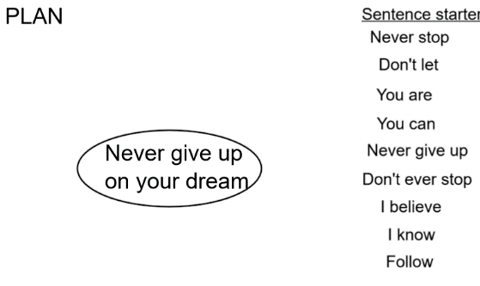
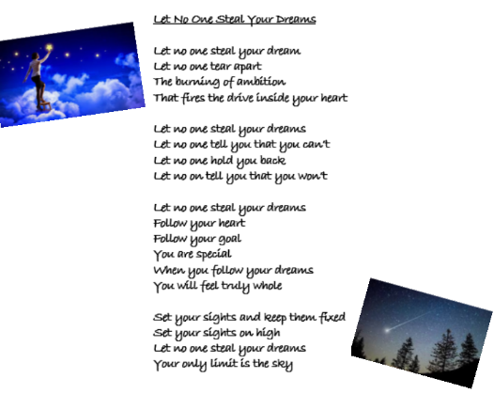
Your task this week is to write a motivational poem. Your poem is aimed for a friend or for somebody who is part of Barnum’s circus. The poem needs to inspire them to never give up on their dream. Watch Miss Zeller’s video and use her modal and success criteria to guide you. Good luck!
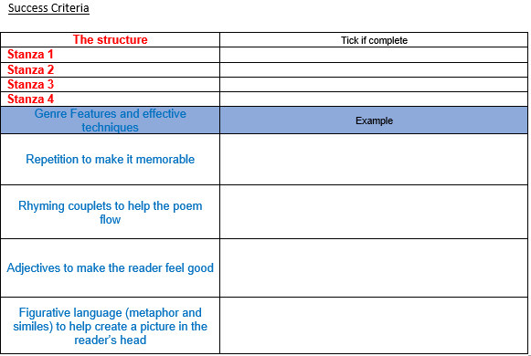

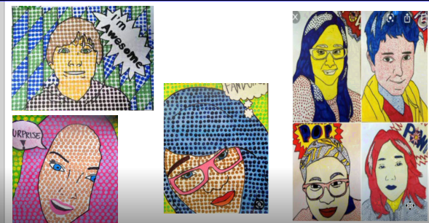
Art

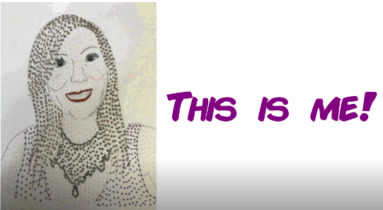
This week in art we will be creating a self-portrait, titled ‘This is me’, in the style of Roy Lichtenstein.
This also ties in with this week’s well-being challenge so e-mail your work to Miss Mallas as well as us.
r.mallas@southdale.wakefield.sch.uk

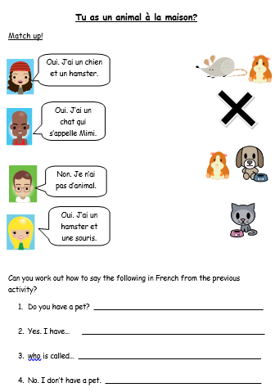
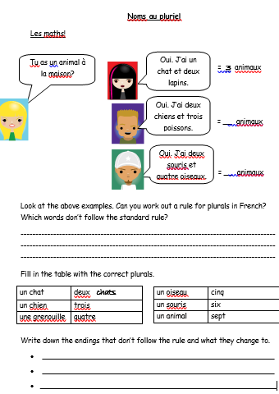

French
In French we are learning to talk about our pets. We are also looking at the rules about making nouns plural.
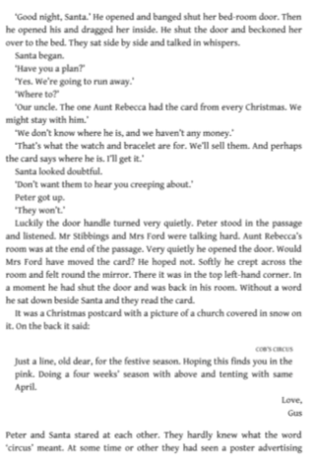
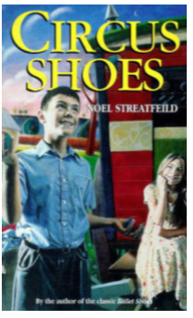
Reading
This week in reading, we will be exploring the book ‘Circus Shoes’.

Maths
This week we are working on adding and subtracting decimals.

Additional Learning
Oak National Academy - Have a go at the science lessons:
https://www.thenational.academy/online-classroom/year-5/foundation#subjects

TTR Battle - Can you get yourself into the top 10 biggest improvers or highest scorers?
https://play.ttrockstars.com/auth

Reading for Pleasure - Mr Mills will continue to read ‘You are Awesome’ by Matthew Syed each day.

