Year 5 – Week beginning 11th May

Narrative Journey
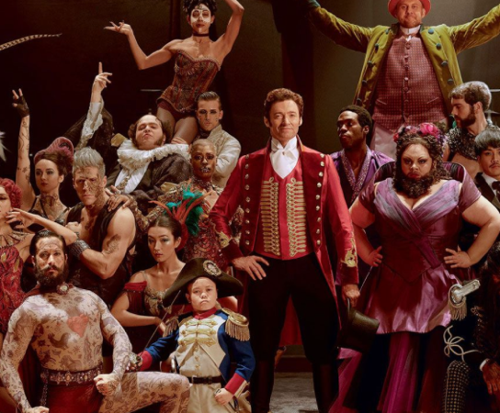
We have been absolutely blown away with the fantastic work you have produced and hope you are enjoying this new narrative as much as we are!

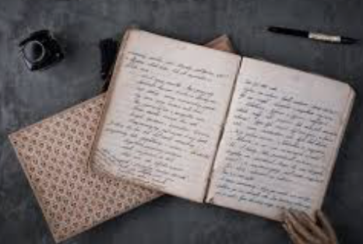
English
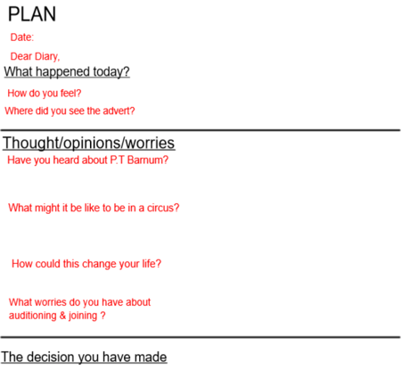
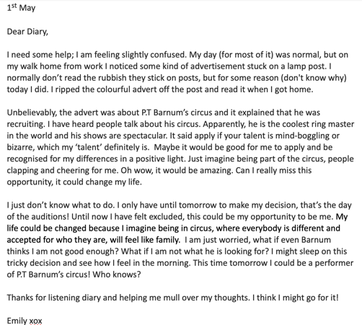
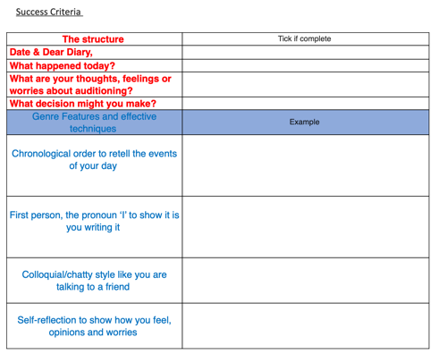
Your task this week is to write a diary entry imagining you have seen the job advert and you are thinking about auditioning for Barnum’s show. You can imagine to be one of the individuals you researched in History last week (Annie Jones, Tom Thumb & Fedor Jeftichew) or just be yourself! Writing a diary entry is like having a chat with your best friend and must include your thoughts, feeling and worries about auditioning and being part of Barnum’s circus. Watch Miss Zeller’s video and use her modal and success criteria to guide you. Good luck!

Music
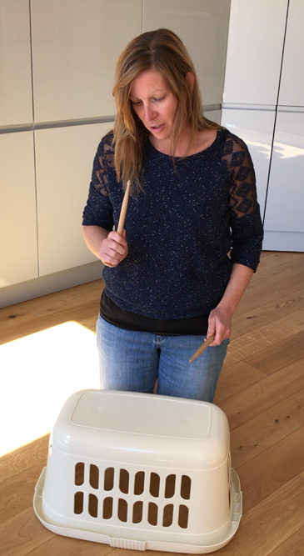
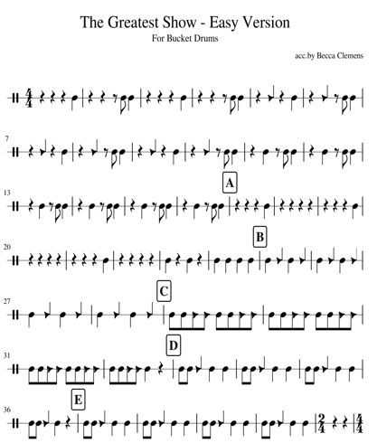
In music, we will be learning how to play a bucket drum to accompany the song ‘The Greatest show’.

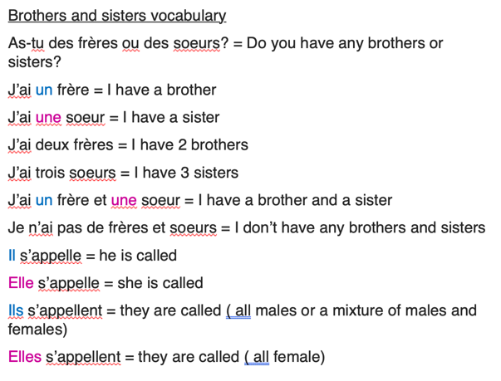
French
In French, we will be learning how to ask and give information about our brothers and sisters.

Reading
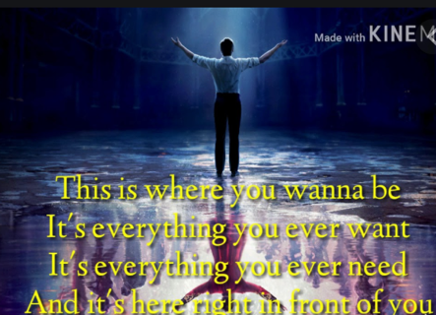
This week in reading, we will be exploring the lyrics to the song ‘The Greatest show’.
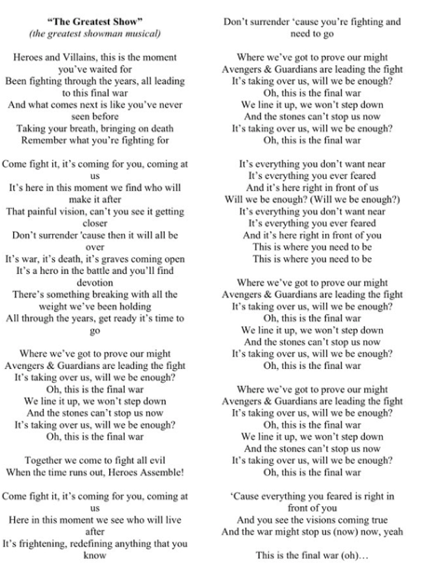

Maths
Monday -WALT: understand percentages as fractions and decimals

Tuesday - WALT: understand equivalents when working with fractions, decimals and percentages

Wednesday - WALT: add decimals within 1.

Thursday – WALT: subtract decimals within 1.

Friday – WALT: add decimals crossing the whole.

Additional Learning
Oak National Academy - Have a go at the science lessons:
https://www.thenational.academy/online-classroom/year-5/foundation#subjects

TTR Battle - Well done to the boys who won last week’s battle. This week all three classes will be playing each other. Which class will come out on top?
https://play.ttrockstars.com/auth

Reading for Pleasure - Mr Mills will continue to read ‘You are Awesome’ by Matthew Syed each day.

