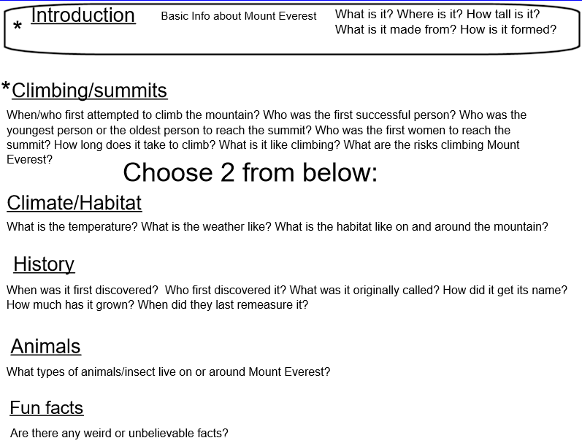

Useful Videos to gather information about Mount Everest
https://www.youtube.com/watch?v=xXo46KlqW78
https://www.youtube.com/watch?v=QqkgKHu1gt0

Websites with videos and information about Mount Everest
https://www.bbc.co.uk/newsround/22702860
https://www.bbc.co.uk/cbbc/joinin/7-things-you-didnt-know-about-everest
https://www.bbc.co.uk/programmes/p02lp4fb

Useful websites to read for information
http://www.alanarnette.com/kids/everestfacts.php
https://www.scienceforkidsclub.com/mount-everest.html
https://www.oddizzi.com/teachers/explore-the-world/physical-features/mountains/seven-summits/everest/
https://www.nationalgeographic.co.uk/2019/02/climbing-mount-everest-explained

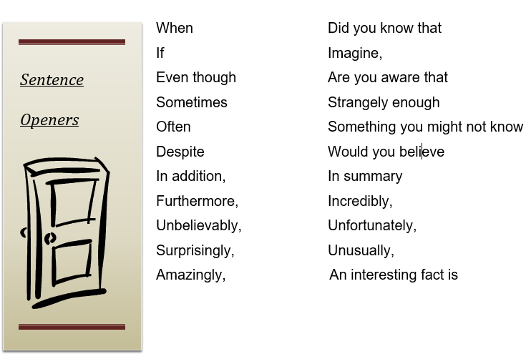

The structure | Tick if complete
Title- to sum up topic
P1- Introduction-basic Mount Everest facts
P2- Climbing/Summit
P3-
P4-
Genre Features and effective techniques | Example
Subheading to organise the text and help the reader navigate it.

Bullet points to order key information.
Sentence starters to help your writing flow
Parenthesis to add extra information ( ) - - , ,
Embedded clause/relative clause to help include further detail.
who, which, that, where

