Diary entry

1st May

Dear Diary,

I need some help; I am feeling slightly confused. My day (for most of it) was normal, but on my walk home from work I noticed some kind of advertisement stuck on a lamp post. I normally don’t read the rubbish they stick on posts, but for some reason (don't know why) today I did. I ripped the colourful advert off the post and read it when I got home.

Unbelievably, the advert was about P.T Barnum’s circus and it explained that he was recruiting. I have heard people talk about his circus. Apparently, he is the coolest ring master in the world and his shows are spectacular. It said apply if your talent is mind-boggling or bizarre, which my ‘talent’ definitely is. Maybe it would be good for me to apply and be recognised for my differences in a positive light. Just imagine being part of the circus, people clapping and cheering for me. Oh wow, it would be amazing. Can I really miss this opportunity, it could change my life.

I just don’t know what to do. I only have until tomorrow to make my decision, that’s the day of the auditions! Until now I have felt excluded, this could be my opportunity to be me. My life could be changed because I imagine being in circus, where everybody is different and accepted for who they are, will feel like family. I am just worried, what if even Barnum thinks I am not good enough? What if I am not what he is looking for? I might sleep on this tricky decision and see how I feel in the morning. This time tomorrow I could be a performer of P.T Barnum’s circus! Who knows?

Thanks for listening diary and helping me mull over my thoughts. I think I might go for it!

Emily xox

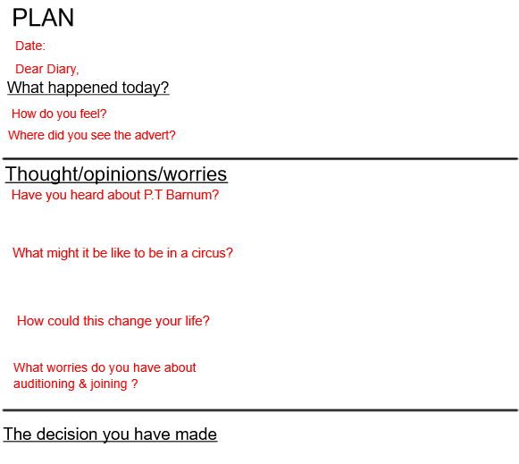

Success Criteria

The structure | Tick if complete
Date & Dear Diary,
What happened today?
What are your thoughts, feelings or worries about auditioning?
What decision might you make?
Genre Features and effective techniques | Example
Chronological order to retell the events of your day

First person, the pronoun ‘I’ to show it is you writing it

Colloquial/chatty style like you are talking to a friend
Self-reflection to show how you feel, opinions and worries

