Year 6 – week beginning 27th April 2020

Narrative Journey
This week it's all about the boat itself! You will be researching the Titanic, following your own interests about this great vessel. You could produce:
- A diagram of the boat (the interior or exterior)
- A timeline of events
- A fact file (size, weight, etc.)
- Make a Lego model!
- Details about the different class of passengers
- What happened to the boat in the years after the sinking
- A map to show the route the Titanic took on its maiden voyage (highly recommended)
- The coordinates task (optional)
Present your findings however you wish - a PowerPoint, poster, filmed presentation... The opportunities are endless! We're can't wait to see what you produce on your own personal voyage.

English
This week we are writing a description of the Titanic’s journey before she hits the iceberg. You need to try and use literary language to make your descriptions as real as possible! Watch Mrs Mohebi’s writing tutorial to see how to do this effectively.

Reading
Our reading lessons this week will be based on extracts from the book, ‘Heroes of the Titanic’. We will start by using book talk techniques to write our thoughts, questions and wonders based on the text. We will explore the effective vocabulary used in them and unpick the definitions carefully. On Thursday we will be checking our understanding of the text by answering some tricky VIPERS questions.

Maths
Monday - WALT: recap multiplying and dividing by 10, 100 and 1000
Tuesday - WALT: recap methods for addition and subtraction
Wednesday - WALT: recap methods for multiplication and division
Thursday - WALT: practise our arithmetic skills
Friday - WALT: correct our misconceptions

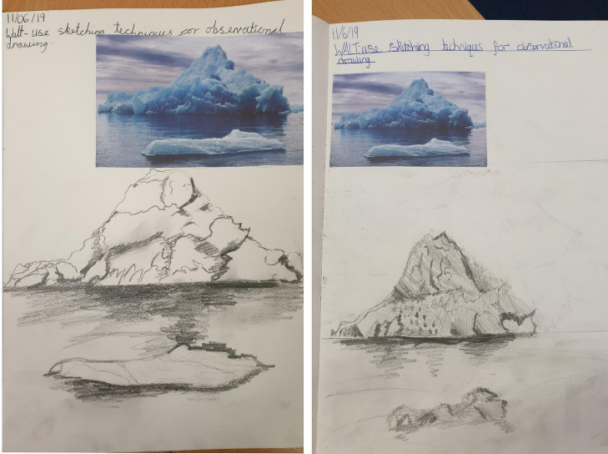
Art
In art this week, we are beginning our second project. Your first task is to use the sketching techniques we have learnt in school to produce an observational drawing of your chosen iceberg. See Miss Ryan's YouTube video for more information!

Additional Learning
TTR – keep practicing your times tables!

