Year 6 – week beginning 20th April 2020

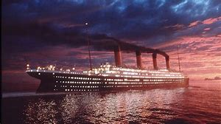
Are you ready to set sail on our next incredible narrative?
Grab your boarding pass and prepare to embark on the ‘Ship of Dreams’ and immerse yourself in the voyage of the ‘unsinkable’ Titanic!

Narrative Journey
Using the list of Titanic passengers, your first task is to choose a passenger from the list and fill out your boarding card. Your second task is to research your passenger. Did they survive their fateful journey? What did they do for a living? Why were they heading to New York? Were they a first, second or third class passenger? Present your findings how you like such as a mind map, bullet points or poster.

English
After seeing Titanic for the first time at Southampton and boarding, we are writing a postcard home to describe what we think of the passenger liner and to document our journey to America to accurately convey the thoughts and feelings of our characters. Our English task will start on Tuesday once you have had chance to start researching your character.

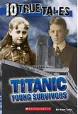
Reading
Our reading lessons this week will be based on extracts from the book, ‘Titanic Young Survivors’. We will start by using book talk techniques to write our thoughts, questions and wonders based on the short eye witness accounts. We will explore the effective vocabulary used in them and unpick the definitions carefully. On Thursday we will be checking our understanding of the texts by answering some tricky VIPERS questions. Reading these texts will also help us to explore the thoughts and feelings of the passengers and support us with writing our postcards home in English.

Maths
Monday – WALT: convert between fractions, decimals and percentages.
Tuesday – WALT: convert between fractions, decimals and percentages.
Wednesday – WALT: find percentages of amounts.
Thursday – WALT: find percentages of amounts.
Friday – WALT: calculate percentage increases and decreases.

Art
Your task this week is to design the reverse side of your postcard by drawing the Titanic itself! Use the video clip to help you have a go at this tricky yet exciting challenge. Can you make yours look 3D too?

Additional Learning
TTR – keep practicing your times tables!
Research the Titanic – there will be an abundance of interesting facts online which could be useful for our learning during this narrative! Who knows what you might discover?

