Example

The Mermaids of Whitby
When Whitby was a quiet fishing town and just populated by a very small number of people, two mermaids washed up on the beach after a dreadful storm. The mermaids had distinctive golden, fiery hair and opal like scales. Beautiful as they were, they also horrified the townsfolk, who captured them and tied them in nets to put them on show. For months, they lived in the rancid, rotting nets and rocks were hurled at them by scared passers-by. The mermaids cried for their freedom and slowly their sparkly glow began to fade and turn to misery. The mermaids swore that once they had regained their freedom, they would punish the town of Whitby for the torture they had endured! Over time, some of villagers began to warm to them and were enchanted by their fascinating beauty. Many young sailors used to gather round the Mermaids and tease them for their immense beauty. One day, the mermaids tricked a drunk fisherman into letting them out of their nets for a moment, but when he agreed, the mermaids made their escape. Never to be seen again...
The seasons changed and the folk of Whitby soon forgot about the mermaids, for they now focused their attention on their cruel industry of whaling. Day after day, large fishing vessels would return from sea full of decaying whale carcasses. The mermaids watched from a secret cove the inhumane, abhorrent behaviour of these fisherman. They made the important decision to avenge the hurt and suffering the fisherman had caused and fulfil their promise of cursing the wretched town.
Night came early and the sky turned menacing black; the mermaids conjured up a storm like no other. Waves as tall as giants battered the sea defences and tore through the heart of Whitby. CRASH, WHOOSH, BANG! The relentless waves destroyed houses and pubs. Many lives were lost. However, more importantly not a single fishermen’s boat was left intact. When storm subsided, the remaining, shaken civilians assessed the damage. They wondered how such a storm could have taken place, when it was summer and there was not a cloud in the sky the night before. On one of the broken masts a fisherman noticed a lock of golden fiery hair. To his horror, he remembered that this was the same as the trapped mermaids from months before. Never again did the town folk mistreat sea creatures…
Legend has it that even today (years later) on a stormy night, in the bitterly cold wind you can hear the hiss of the mermaids curse and the shriek of the sailor that lost their lives that night!

Websites with Whitby ghost stories
https://www.visitwhitby.com/blog/whitby-ghosts/

http://myths.e2bn.org/mythsandlegends/userstory5553-whitby-abbey.html

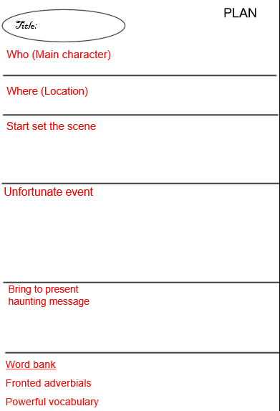

Extra word banks
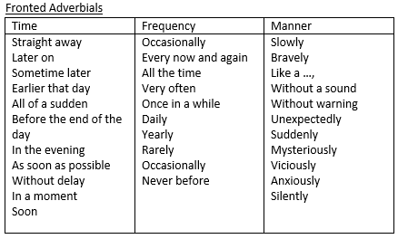

Success Criteria for Ghost story
The structure | Tick if complete
Set the scene
Unfortunate event takes place
Bring story to present haunting message
Genre Features and effective techniques | Example
Clear opening sentence to set the scene of Whitby
Detailed description (specific and precise adjectives)to show the horror of the character/event
Fronted adverbials to illustrate the change in time
Short sentences to create suspense
Powerful punctuation, such as … to create mystery
Onomatopoeia to bring the story to life

Description of the weather to create an unsettled atmosphere (Pathetic fallacy)
Figurative language (metaphor or simile)to help the reader visualise

