Video (Watch first 30 sec – 1 min)
https://www.youtube.com/watch?v=pp5ZsGEg-0M

WALT: Write a description of the circus
Example
Through the darkness, they could see it. The bright lights. They had made it to the most exciting show on earth! Darting away from their parents, the children dashed towards the famous stripes, unaware of the splash marks staining their clothes. The giant tent towered above the cars which had been parked with reckless abandonment. As they approached the opening, they knew all their dreams were about to come true…
Smoke billowed out as the expectant crowd waited. Gasps could be heard as a figure leapt through the clouds. It was him. P.T Barnum. Before the crowd could even catch breath, the cavalry arrived in the shape of four, majestic horses, upstaged by the flamboyant headdresses their riders wore.
As the smoke continued to billow, elephants adorned in red and gold sashes emerged, like book ends either side of the entertainers. This was it. The greatest show had begun! P.T Barnum led them out, orchestrating every movement. Cheers and gasps in equal measure could be heard from the crowd as their eyes went this way, then that, trying to keep up with the action. Never had a show been as awesome as this!

Plan circus description
- 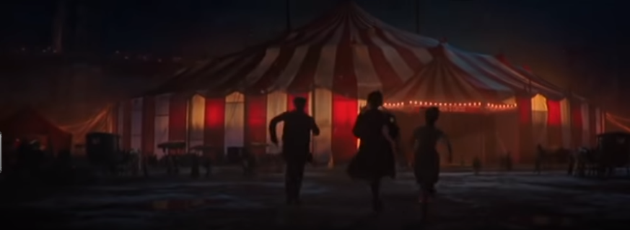

- 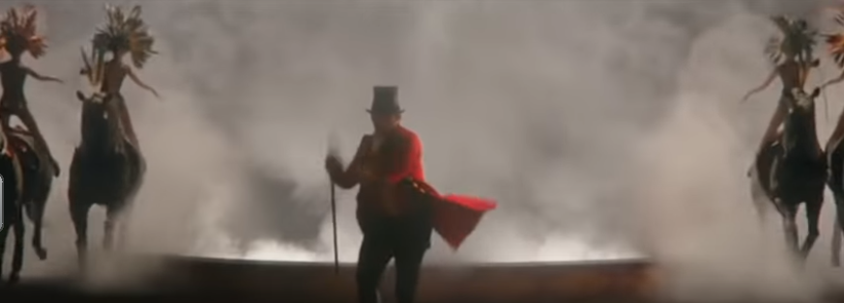

3. 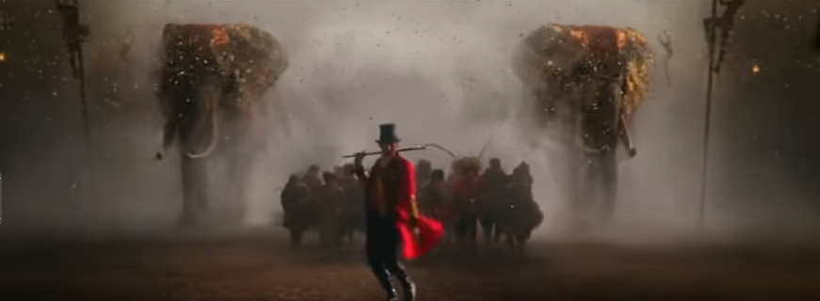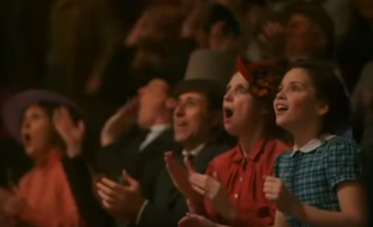

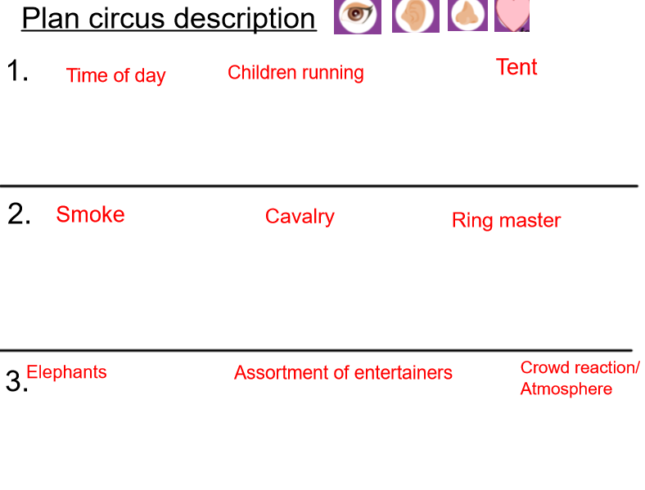

Success criteria for description
The structure | Tick if complete
- Outside the circus tent
- Show beginning
- Further description about show
Genre Features and effective techniques | Example
Detailed description (powerful adjectives) to show the wonderment of the show/entertainers
Fronted adverbials to vary sentence starters
Short sentences to create suspense
Powerful punctuation, such as … and ! to create excitement
Use of senses (sight, smell, noise and feeling)

