WALT: Make inferences from pictures and videos.
- Look at the paragraph beginning ‘Looking up, Barnum’s furrowed brow…’
What shows you that Barnum is feeling hopeful as he looks at his troupe? (2 marks)
What he said:
What he did:
- Using the text and the scene that you have watched, identify two things that show you how the atmosphere changes
throughout the scene? (2 marks)
- Which sentence below best describes the portraits? (1 mark)
They were all pictures of his close family
They were of kings, queens, politicians, famous people and his family
They had been there for a very long time
They were people he didn’t really know

- a roaring chorus of cheers and song reverberated between the antiquated walls
What does the word reverberated mean in this sentence? (1 mark)
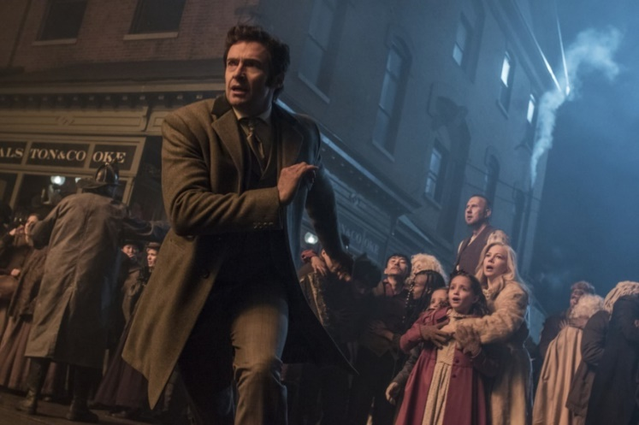
loudly
stopped
echoed
ran

- Looking at this image, can you describe what might be happening? Justify your answer, referring to the image.
(Clue: facial expressions and body language) (2 marks)

- Look at the paragraph beginning ‘Standing still for a split second, Barnum’s eye was…’ and watch the clip.
What shows you that Barnum has decided to go and look for his family? (2 marks)
What he saw:
What he did:

