Year 5 – Week beginning 20th April

Narrative Journey
Our Whitby inspired narrative - looking specifically at whales and the whaling industry - rolls on this week as all our work so far is starting to come together; but we’re not done yet! We’re going to be writing ghost stories in English to put on our websites all about Whitby and these will complement the fantastic artwork you have done. What other information could be posted on our website to educate people about the town of Whitby? Can you find out some more fascinating facts about this once thriving Yorkshire town?

English
Your task this week is to write a ghost story about Whitby that we can post onto our Whitby website.
Make sure you use Miss Zeller’s model and the success criteria to guide you. To help your further, make sure you check out the websites Miss Zeller gave you in the English video to inspire you.
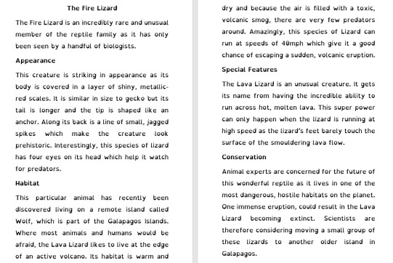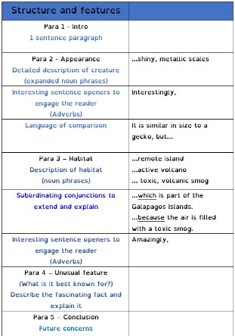

Art
We would love to see more of your Whitby Abbey art work. Research the work of artist Rita Readman and see if you can replicate some more of her Whitby artwork.

Reading
In guided reading, we will look at a text called ‘The Phantom Coach’ and then on Thursday a second text called ‘The Brave Lighthouse Keeper’. Listen to and read this week’s extract and follow the 20 minutes lessons for Mon-Thur.
Mon – Read as a reader  (This involves children thinking about the text as they read it and verbalising any thoughts, feelings and questions that they may have. It is a really important time to discuss and explain any language they may not understand). | 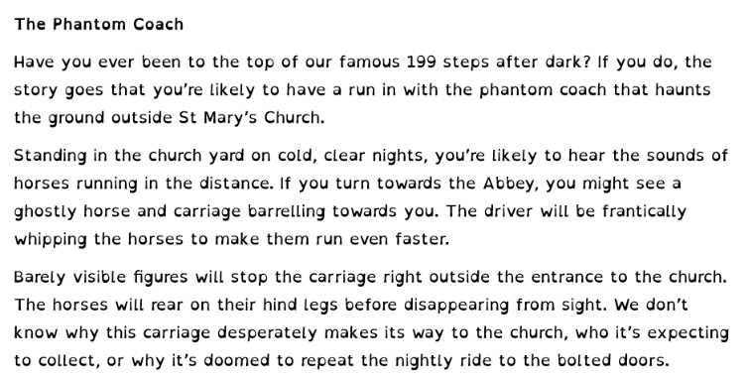
Tue – Vocabulary  (This session involves making sure the children understand  the vocabulary used) | 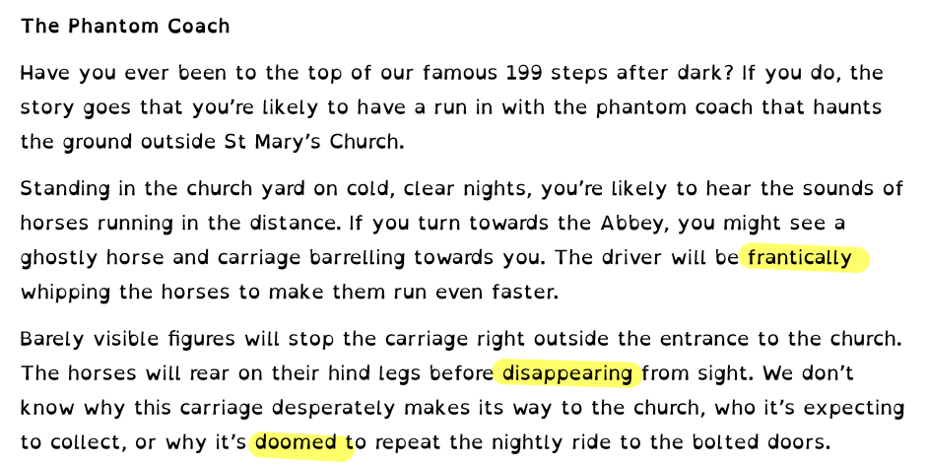
Wed – Create own Questions
In this session, children can create their own questions to respond to.

Thursday – Comprehension  Skills | 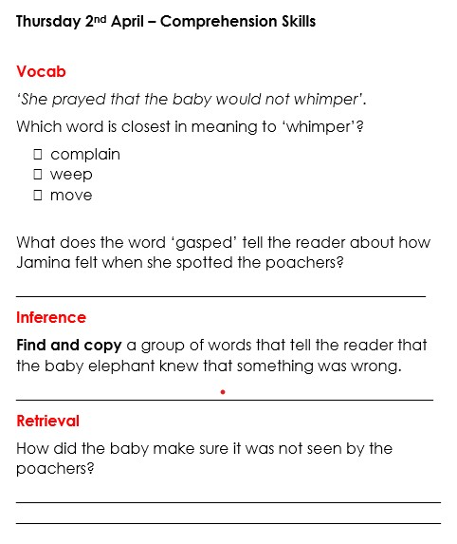

Maths
Monday -WALT: add 3 fractions.
Tuesday - WALT: add mixed number fractions.
Wednesday - WALT: subtract fractions.
Thursday – WALT: subtract mixed number fractions
Friday – WALT: multiply fractions by whole numbers.

Additional Learning
TT Rock stars – Let’s win some battles!!

