Year 5 – Week beginning 27th April

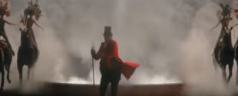
Narrative Journey
Are you ready for the greatest narrative on earth? This week we are launching our brand new ‘Greatest Showman’ inspired narrative.

English
Your task this week is to write a description of PT Barnum’s exciting circus, to portray his dream.
Make sure to watch the first 30secs-1min of the Youtube video (https://www.youtube.com/watch?v=pp5ZsGEg-0M) showing PT Barnum’s circus to inspire you. To help your further, make sure you use Miss Zeller’s model and the success criteria to guide you. Good luck!
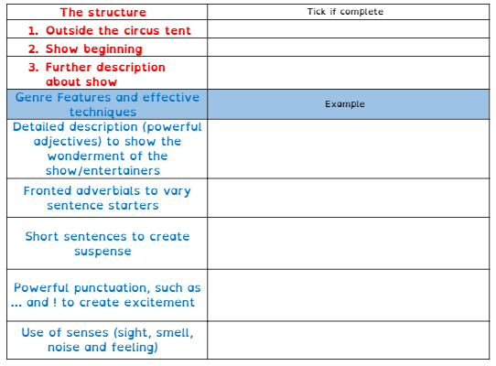
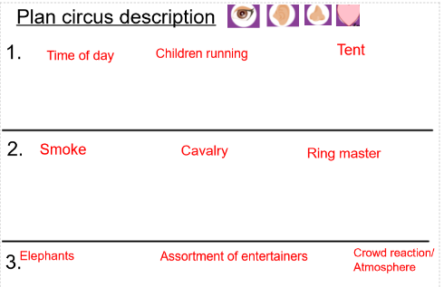
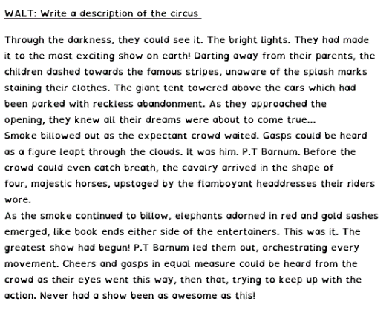

Art

For Art we will be looking at the main features found in Circus advertising and why the use of colour is important in advertising. You will then be given the challenge of creating your own Circus advert!

French
For French you will be revising how to introduce your family members. You’ll be playing £1000 drop so make sure you have done some quick revision of family members and how to introduce them in French before you play!

Reading
In guided reading, we are looking at a text called ‘From Now On’ We will look at the extract but we have also included a link for you to watch this extract performed as a song. Read as a reader
(This involves children thinking about the text as they read it and verbalising any thoughts, feelings and questions that they may have. It is a really important time to discuss and explain any language they may not understand).

Tue – Vocabulary
(This session involves making sure the children understand
the vocabulary used)

Wed – Create own Questions
In this session, children can create their own questions to respond to.

Thursday – Comprehension
Skills

Maths
Monday -WALT: multiply mixed number fractions by whole numbers.
Tuesday - WALT: find fractions of amounts.
Wednesday - WALT: understand decimals as fractions
Thursday – WALT: understand thousandths
Friday – WALT: round decimals

Additional Learning
Research about the life of PT Barnum
French learning video
Art Learning video

