Homemade Rubbery Goop Recipe
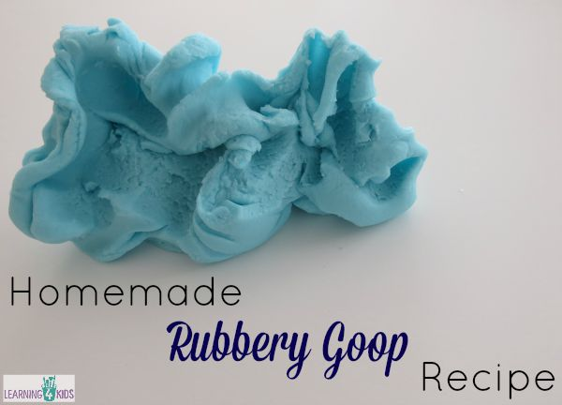
The kids are going to love this!!! Homemade Rubbery Goop is perfect for sensory play opportunities as it is safe and non-toxic using basic ingredients found in your pantry.
Rubbery Goop looks and feels like basic play dough but it is textured differently. It is smooth, soft and slightly stretchy. Moulding it in the hands is very addictive as the texture is delightful. It is so much fun to play with, you can pull the goop apart and roll it back together to form a smooth ball. You can squeeze it and it will squish through your fingers

How to make Rubbery Goop?
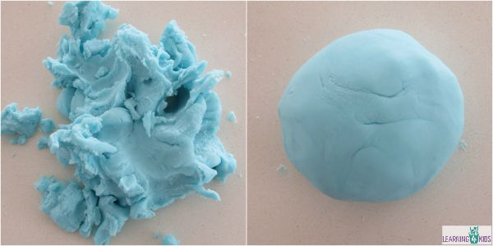
Rubbery Goop can be stretched and pulled apart into smaller pieces (not dry or crumbly) and it all rolls back up into a smooth soft ball.

Ingredients:
2 cups bi-carbonate soda (baking soda)
1 ½ cup water
1 cup of cornflour (corn starch)
Food colouring (optional)

Instructions:
- Combined all ingredients into a saucepan.
- Mix the ingredients together using a whisk to remove lumps.
- Heat on stove stirring with a wooden spoon.
- Bring the mixture to the boil continuously stirring.
- Small lumps will begin to appear, continue to stir until a thick mixture has formed.
- Turn out onto the bench. Be careful the Rubbery Goop will be very hot!
- Knead together to form a smooth ball of Rubbery Goop.
- Store in a plastic zip-lock bag or air tight container.
There are no preservatives in this recipe and depending on how many children play with the Rubbery Goop, it can last up to two weeks.

Let’s Play
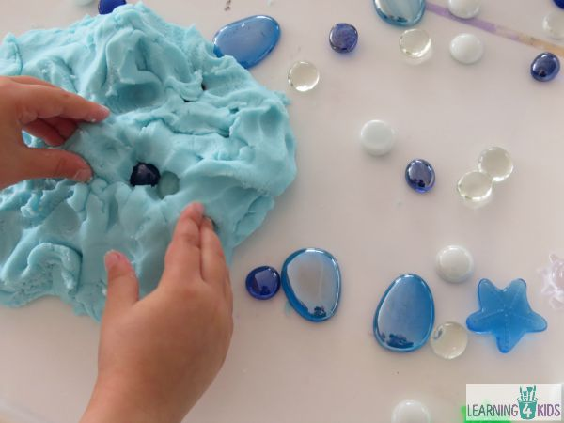
Rubbery Goop can be played with much like play dough. It is soft, stretchy and easy to mould and shape.

Some Ideas:
- Play with Rubbery Goop much like play dough using rolling pins, play scissors and cookie cutters.
- Add gemstones, bottle tops, shells, toy cars, dinosaurs or any other nick knacks from around the house.
- Use descriptive language to describe the experience, how does the Rubbery Goop feel? It feels soft, smooth and stretchy.

Let’s Learn
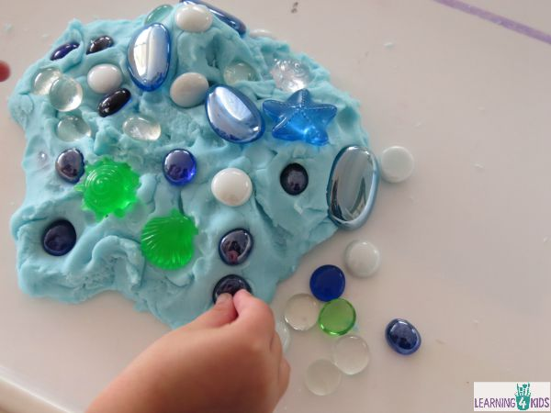

Learning Opportunities
- Creativity and imagination
- Fine Motor Development
- Hand-Eye Coordination
- Sensory- Development of the sense of touch. Feeling and manipulating objects.
- Oral language development- using descriptive language.

How to Colour Rice for Sensory Play
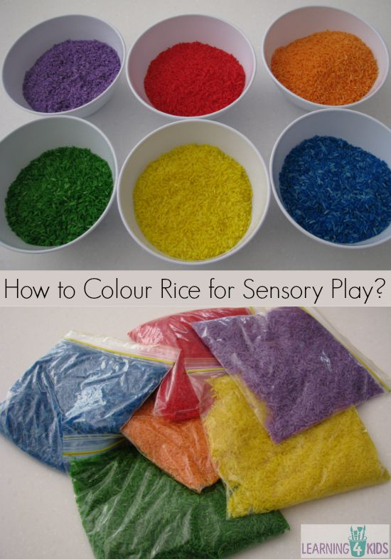

What you will need?
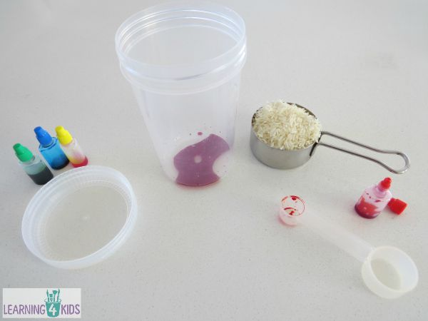
1 cup dried rice. (I use jasmine rice because I love the smell!)
1 teaspoon food colouring (I have also used diluted paint before with the same outcome.)
Paper towels
Tray or plate (this for drying the rice)

Step 1:
- Add food colouring to the container and pour in one cup of rice.
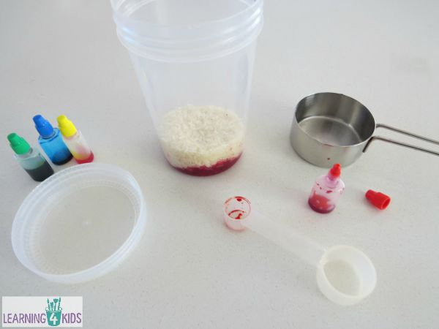

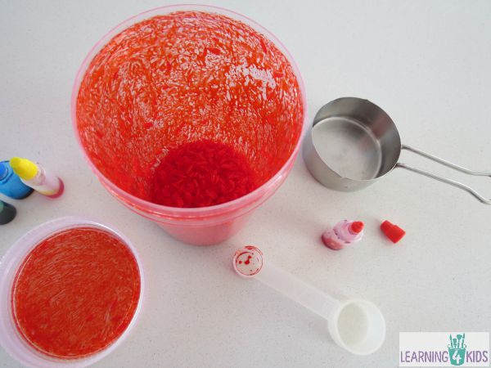
Step2:

- Screw on the lid and shake, shake, shake until the rice is completely covered.
- Add a little more food colouring if needed to achieve desired colour.

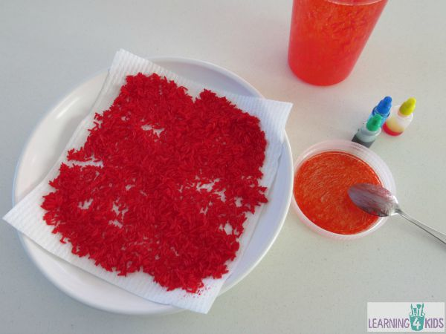
Step 3:

- Place the wet rice onto a paper towel and plate.
- Using a spoon spread the wet rice out evenly to dry out. If it is a sunny day, I place the wet rice out in the sun to air dry.
- Give the container a wipe and a rinse, and proceed with your next colour!

Step 4:

- When the rice is dry, gently rub the rice between your fingers to break up any rice that may be stuck together.
- Coloured rice will last for several years if stored correctly in an air-tight container. We have had our rainbow rice for nearly 5 years and it is still good to use.
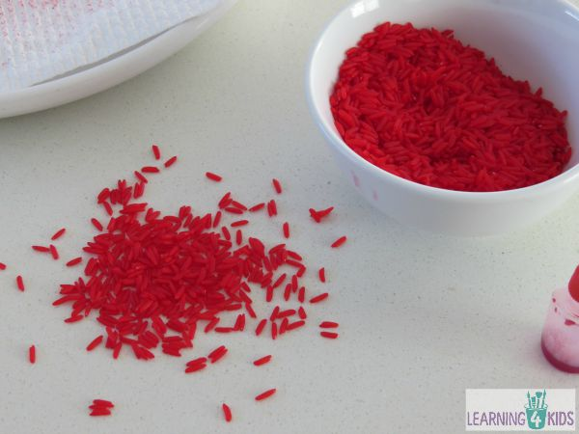

Bucket of Colourful Spaghetti Worms Sensory Play

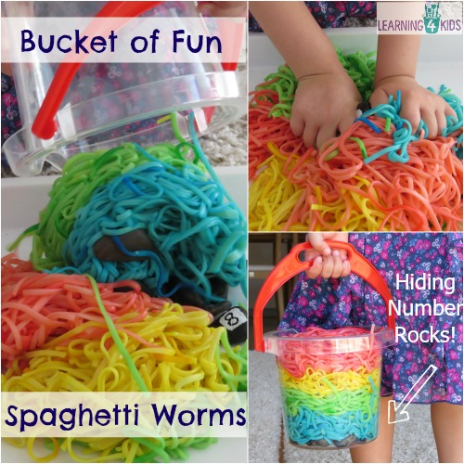
Sensory fun and messy play at its best!
A bucket filled with coloured spaghetti worms with hidden number rocks is a motivating learning experience for kids to explore numbers and their senses.
Sensory play helps children to develop and improve their gross and fine motor skills, co-ordination and concentration. It also provides an opportunity to use all their senses to discover and explore their environment, develop their imagination and creative thinking.

What will you need?
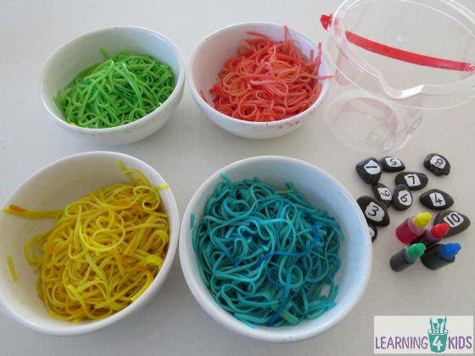
You will need cooked and cooled spaghetti, large tray, pebbles, small bucket or container, food colouring, liquid paper and a permanent marker pen.
To colour the spaghetti, place approximately 8 drops of each colour food dye into separate bowls. Evenly share out the cooled spaghetti into the bowls and gently stir until the colouring has evenly dispersed. Add more colouring for depth in colour, if desired.
To make the number rocks, we painted on liquid paper to create the base for writing the numbers. Once this was dry we added a second coat of liquid paper to the pebbles and then directly wrote the numbers on using a permanent marker.

Let’s Play
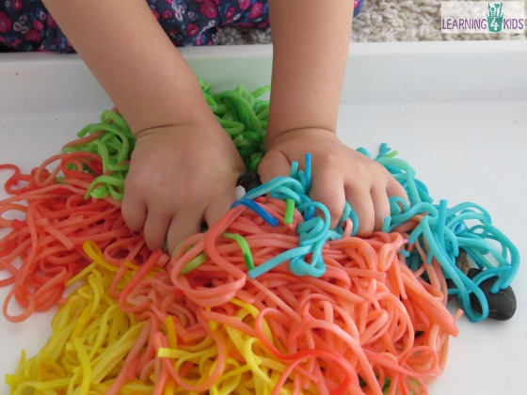

Some Ideas:
- Lots of squeezing, squishing and manipulating fun exploring the textures of the wet, slimy spaghetti worms.
- Sensory play is a great opportunity for kids to explore language and use descriptive words. Words to describe what they are experiencing, their senses and what they are feeling; slippery, slimy, soft, squishy and sticky.
- Search for the hidden number rocks in the spaghetti worms. Start searching at the beginning with number 1 and hide the numbers you are not looking for back into the spaghetti worms. As your child finds each number, place them in order from 1 – 10 along the tray. Point at each number and count out loud.
- Talk about the number shapes and how each number looks, such as number 5 looks like it has a big tummy. Funny little things like this help children learn their numbers as they associate it with something familiar to them.

Tip
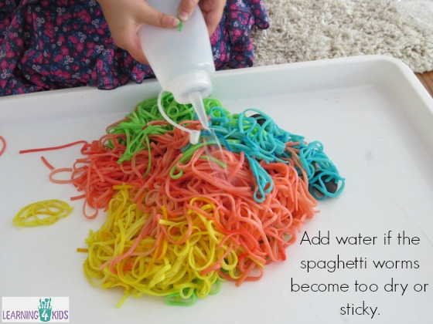
If the spaghetti becomes too dry and sticky, have some water handy to squirt onto the pasta to help keep it smooth and slippery to handle.

Let’s Learn
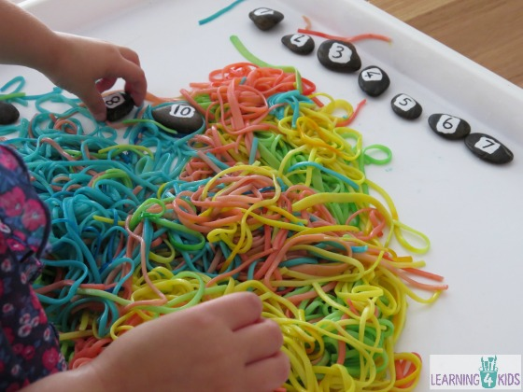

Learning Opportunities:
- Concentration.
- Mathematics – number recognition and number sequence.
- Problem solving and overcoming challenges.
- Sensory play encourages children to manipulate and mould materials, building up their fine motor skills and coordination.
- Sensory play is unstructured, open-ended, not product-oriented; it is the purest sense of exploratory learning.
- Self-esteem: sensory play offers kids the opportunity for self-expression because there is no right answer and children feel safe to change or experiment with what they are doing.
- Language development – experimenting with language and descriptive words. Also counting out loud.
- Encourages imagination and creative play.

How to make Squishy Sensory Bags?
Squishy bags are perfect for sensory play without the mess.
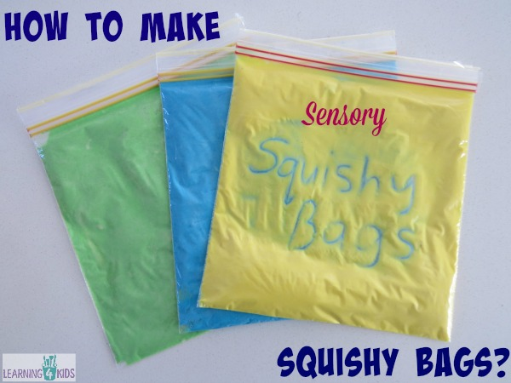
The squishy bag is perfect for practicing letters, numbers, name writing, drawing pictures, shapes and words. Your child can practice hand and finger movements for pre-writing development on the squishy bag.
There are so many different ways to make squishy bags, I have seen others use glue, paint, hair gel, baby oil and shaving cream. Today I am sharing with you how we made our Squishy Sensory Bags using flour, water and food colouring.

What you will need?
For one sensory bag, you will need 1 cup of flour, 6 tablespoons of water and food colouring. You will also need zip-lock lunch bags (22cm x 22cm), sticky tape and a small mixing bowl.
Adjust the flour and water amounts if you are using a smaller or larger zip-lock bag.
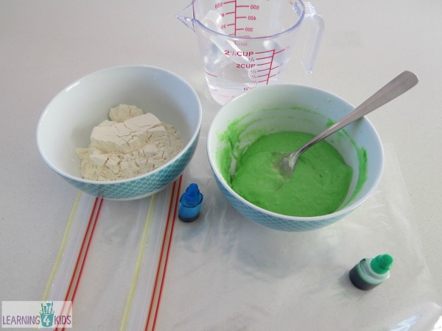

Step 1:
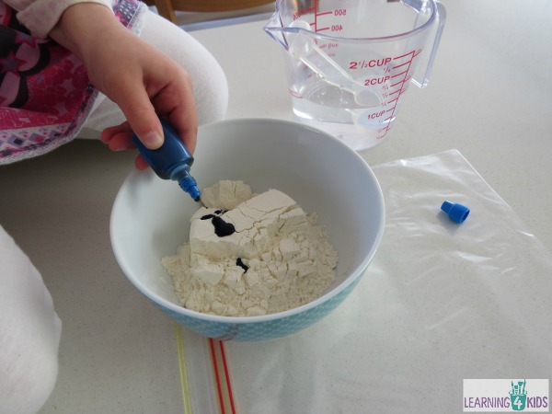
- Place flour into a small bowl.
- Add food colouring.

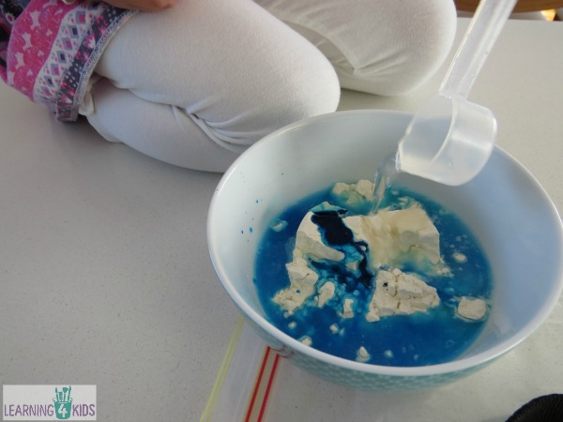
Step 2:

- Now add the water.

Step 3:
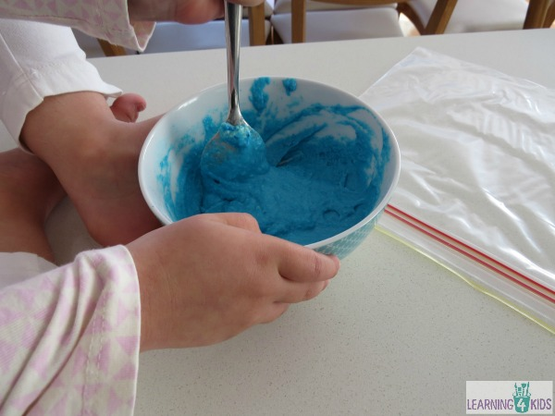
- Mix until all the ingredients are well blended.

Step 4:
- Scoop the flour mixture into the plastic zip-lock bag.
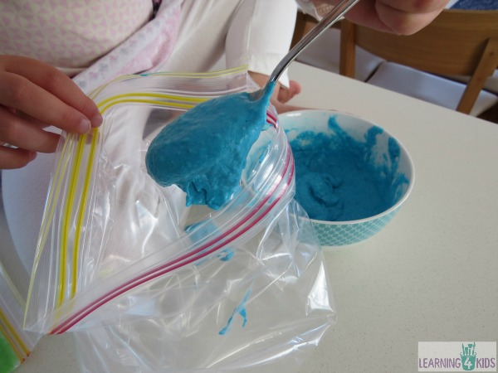

Step 5:
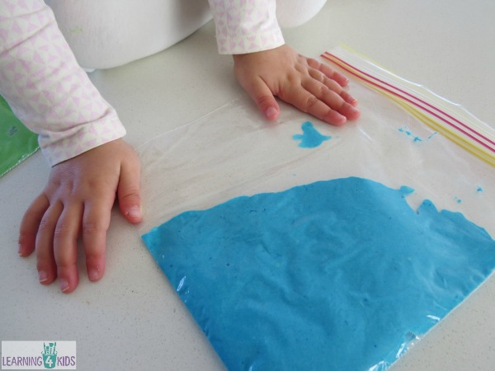
- Before fastening the end, place the squishy bag onto a flat surface.
- Gently push any excess air out to avoid air bubbles.

Step 6:
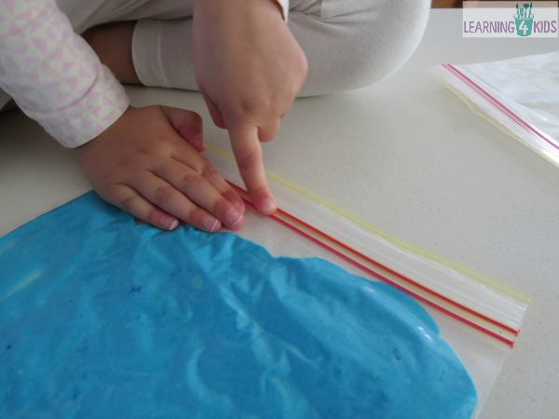
- Press the clips of the bag closed and ensure there are no holes.

Step 7:
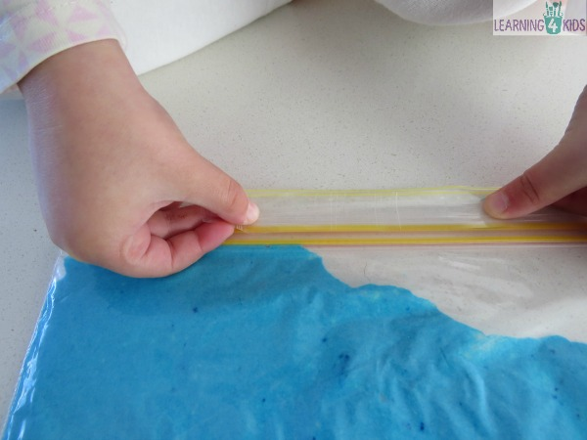
- Place sticky tape along the opening to secure the opening.

Play Ideas

Some ideas:
- Place the squishy bag onto a light table/panel.
- Use your finger, soft paint brush or a cotton wool bud (Q-Tip) to write your name, letters, numbers and shapes.
- Explore the squishy bag for a sensory experience, watch what happens as you squeeze, squish, press, etc. Cause and effect, one action creates a another reaction

How to make Sand Foam?

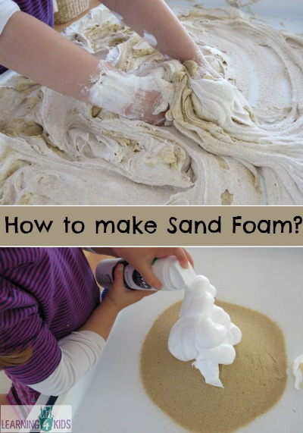
Sand Foam is perfect for sensory exploration. It is made up using only two ingredients, sand and shaving cream.
Kids will love running their hands and fingers through the fluffy, textured mixture.

What you will need?
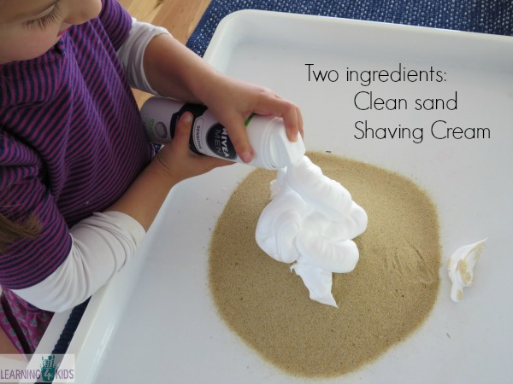
You will need clean sand, shaving cream and a large tray or tub.
There are no real defined amounts for the ingredients, the sand and shaving cream amounts can be adjusted until you are happy with the consistency. We started off with 3 cups of sand and 200ml of shaving cream; however, we added another 3 cups of sand to our mixture to explore what would happen.

Instructions:
- Add 3 cups of sand to the tray.
- Gradually add the shaving cream and combine using hands. Add more shaving cream until desired consistency is made.

Let’s Play
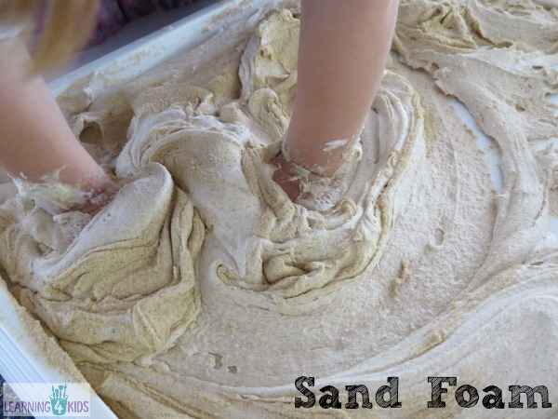

Some Ideas:
- Add dinosaurs, shells and toy cars to extend the play and encourage imaginative play stories. The shells would make a great beach theme activity, the dinosaurs to create a sandy dinosaur world and the toy cars creating roads or moving sand construction site.
- Hide plastic alphabet letters, numbers or other items to create a hide and seek game.
- Use descriptive language to describe the experience, how does the sand foam feel? It feels soft, fluffy and gritty.
- Draw and write in the sand foam tray. You can write your name, letters, numbers, draw shapes and pictures.

Let’s Learn
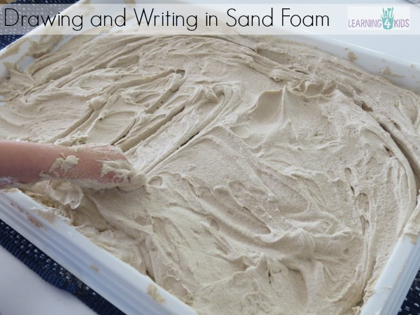

Learning Opportunities
- Creativity
- Fine Motor Development – Pre-writing skills
- Hand-Eye Coordination
- Sensory- Development of the sense of touch. Feeling and manipulating objects.
- Oral language development- using descriptive language.
We plan to repeat this activity but next time using coloured sand and maybe a touch of glitter too!

Mixed Beans & Peas Sensory Tub
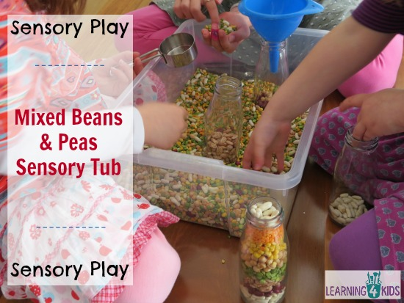
Sensory tubs are such great teaching tools and when I was recently cleaning out our pantry, I found a couple of mixed soup packets that were out of date and decided to make a colourful Mixed Beans and Peas Sensory Tub. Kids love to explore, investigate and play in an unstructured way and sensory tubs are perfect for this exploration.

What you will need?
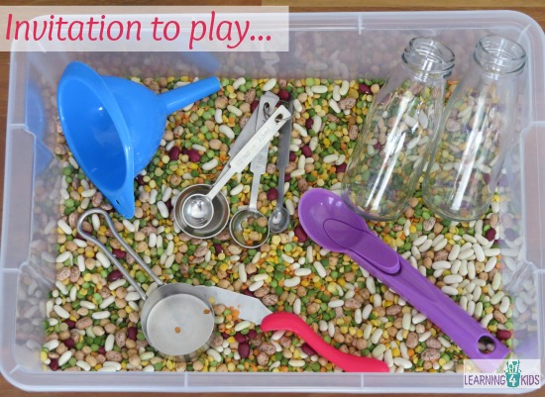
You will need a medium size tub, spoons, scoops, cups, funnels and jars. You will also need a mixture of dried beans, peas and lentils. We have used left over packets of different soups mixes that were no longer in date and re-purposed them for this learning experience.
This sensory tub can be re-used several times for future play experiences by storing the bean and peas mixture tub with a lid. We have a sensory rice tub that we have had now for nearly 3 years and still able to play with it today.

Let’s Play
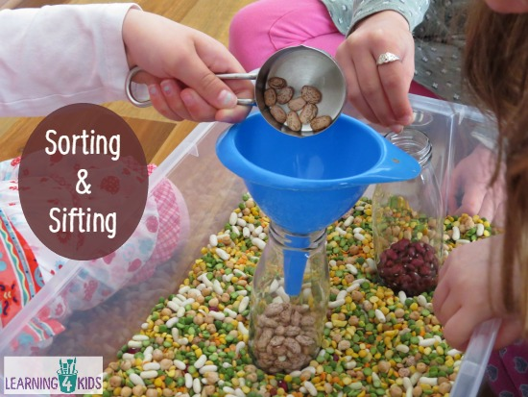
My girls were fascinated by the different beans, peas and lentils. They have seen some of them before and others not so much and really wanted to taste them. Each of them tried the different beans, peas and lentils and discovered they were hard and crunchy, and not very tasty.

Some Ideas:
- Scoop, sift and pour the bean, pea and lentil mix.
- Search for different colours and place them into different containers.
- Layer the different coloured beans, peas and lentils in the jars.

An extension idea
Place each of the different beans, peas, lentils onto a water soaked paper towel on a plate and watch what happens.

Let’s Learn
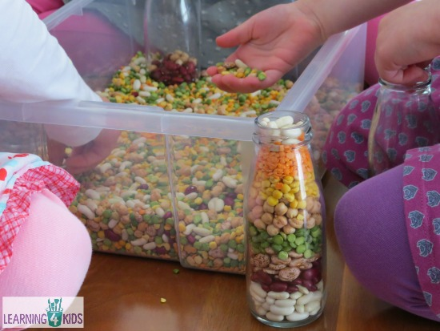

Learning Opportunities
- Fine Motor Development
- Hand-Eye Coordination and Control
- Cause and Effect
- Concentration
- Spatial awareness – experimenting with shape and space
- Language development – shape names
- Mathematics – capacity, measurement

How to make Cloud Dough Recipe

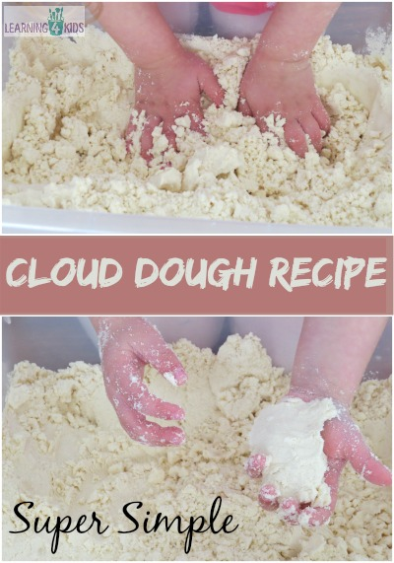
Cloud Dough which can sometimes be called Moon Sand is a homemade mixture used for sensory play experiences.
The consistency of Cloud Dough can be powdery like flour and also mouldable, a bit like damp sand. It is perfect for moulding, shaping, squeezing, pressing and sculpting into different shapes.Cloud dough has a silky smooth texture and scented by the baby oil. It provides a great hands-on sensory learning experience for children.

What you will need?
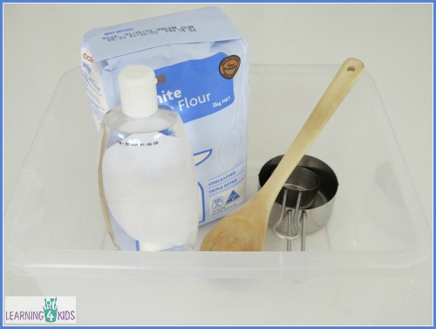
4 Cups of Plain Flour
½ Cup Baby Oil
Large tub and wooden spoon for mixing
To download and print this recipe, click here: How to make Cloud Dough Recipe
This recipe provides a descent amount of cloud dough for one or two children to play with. I double this recipe when using it in the classroom for 3 or more children at one time.

How to make it?
- Measure and pour the flour into the large tub.
- Add baby oil.
- Mix with a wooden spoon.
- Using your fingers, squeeze and press the cloud dough to blend the oil throughout the flour.
- Store in an air tight container.

Please Note:
Please always supervise young children around things that they may place into their mouths. Baby oil should not be ingested.

Learning Opportunities:
- Creativity
- Fine Motor Development
- Hand-Eye Coordination and Control
- Cause and Effect
- Concentration
- Spatial awareness – experimenting with shape and space
- Language development – shape names
- Mathematics – capacity, measurement
- Scientific concepts and skills
- Imaginative Play

Playing With Gloop
+
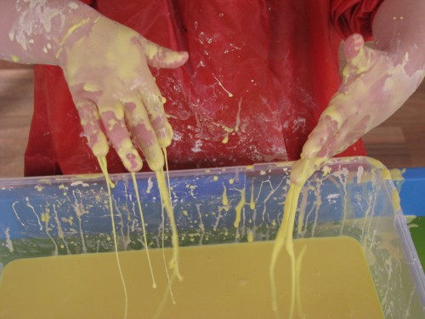
If you haven’t made Gloop yet, then this is a must for any toddler or child to try. It is super fun and super messy, I am not sure who had the most fun, me or the kids!!
Gloop is an interesting mixture with a unique texture to explore and play with.
Playing with Gloop is a fabulous sensory and science activity to learn about the concepts of what a solid and liquid is.

What you will need?
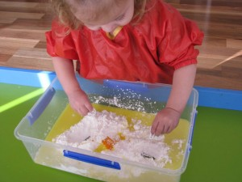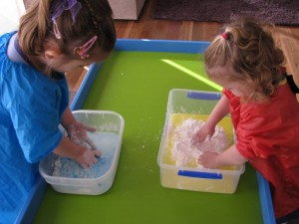
You will need 2 cups of cornflour, 1 cup of water, two drops of food dye and a large container. Encourage your child to mix and play with the Gloop before it is completely mixed together, the fun and learning starts here. Explore the texture and talk about what it feels like, sticky, slimy, cold and powdery.
To see full instructions on how to make Gloop, click here: How to make Gloop?
Tip: This activity can get messy but clean-up is quite easy as gloop can be picked up or wiped off the table and easily washed of hands and clothing. I would recommend wearing an apron.

Let’s Play
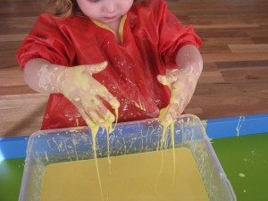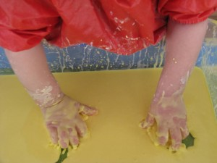
Miss 4 and Miss 22 months had so much fun exploring the behaviour of the gloop, how it drips from her fingers and how hard is hard when pressure is applied. Miss 22months loved running her fingers through the gloop and watching the effect it had.

Let’s Learn
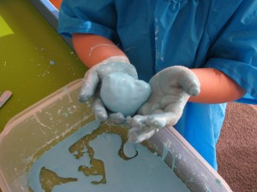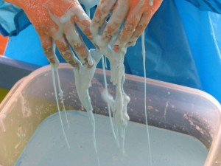
Here is Miss 4 making a ball of gloop by applying pressure but as soon as she stopped pressing in between her hands the gloop acted became runny. It was so much fun to watch as they discovered what the gloop did as they played and experimented with it.
This is a great opportunity to explore more descriptive words: what does the gloop feel like? It feels soft, gooey, slimy, runny and hard.

Let’s Explore
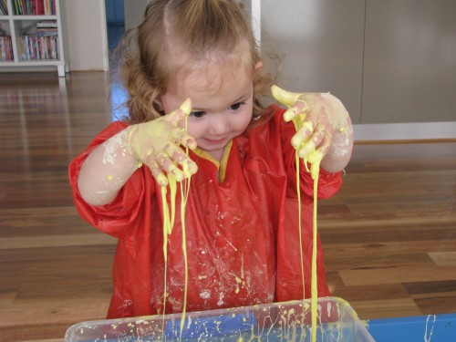

Understanding Gloop – What’s Is Happening?
Solid or Liquid: Cornflour is made of lots of long, stringy particles. When water is added they do not dissolve in water, but they do spread themselves out. This allows the gloop to act both like a solid and a liquid. When you roll the mixture in your hands or apply pressure to it, the particles join together and the mixture feels solid. But if it is left to rest or is held up and allowed to dribble, the particles slide over each other and it feels like a liquid.

Sensory play promotes many learning experiences:
- Sensory play encourages children to manipulate and mould materials, building up their fine motor skills and coordination.
- Sensory play uses all 5 senses, but the sense of touch is often the most frequent. Toddlers and children process information through their senses. They learn through exploring these.
- Sensory play is unstructured, open-ended, not product-oriented; it is the purest sense of exploratory learning
- Self-esteem: sensory play offers kids the opportunity for self-expression because there is no right answer and children feel safe to change or experiment with what they are doing.
- Language development- experimenting with language and descriptive words.
- Develop social skills: practising negotiation skills, turn taking and sharing. Provides opportunities for working out problems and experimenting with solutions.
- Encourages Imagination and creative play.

Green Sandy Play Dough Shape Monsters
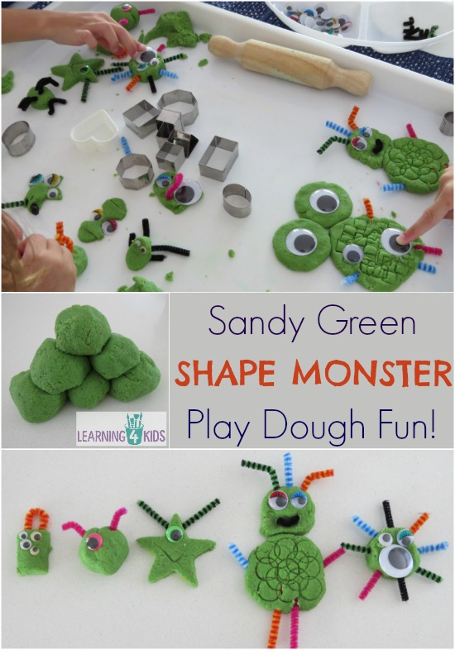
Play Dough is such a fun learning tool to play with and explore new concepts. It also provides children with the opportunity to play creatively and imaginatively using the tools provided.
Recently we made a new play dough recipe, No Cook Sandy Play Dough. The play dough turned out into some fun, green, speckled and textured play dough which was perfect for creating play dough monsters. We added some shape cookie cutters to the play opportunity to continue our learning and understanding about shapes and this is how we ended up with Green Sandy Play Dough Shape Monsters.

What you will need?
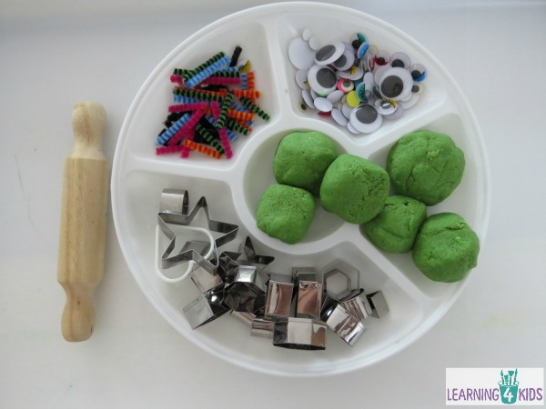
You will need play dough, shape cookie cutters, assortment of sizes wiggly eyes and pipe cleaners cut into different lengths.
The play dough recipe we used for our Shape Monsters is here –> No Cook Sandy Play Dough Recipe

Let’s Play
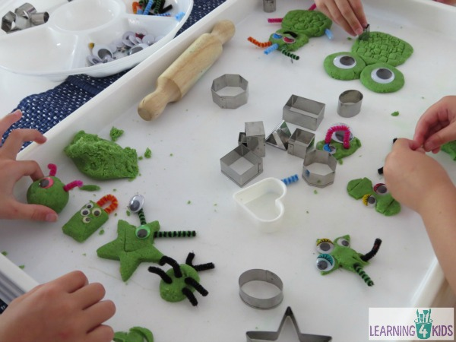

Some Ideas:
- Create Shape Monsters using the tools provided. Children are invited to create feely, creatively and imaginatively using the shape cookie cutters, wiggly eyes, pipe cleaners and play dough.
- Talk about the process of making a shape monster and ask questions. What are you doing? How do you think we should do that? What item will you need? Name the play dough tools you are using.
- Name the monsters using the shape as part of the name, for example we made a monster using the star shape and named it Starry Eyed Monster.
- Make up stories about the monsters, where did they come from? Have a monster play dough party!
- Place the monsters in order from smallest to biggest.
- Place the shape monsters into a line from the monster with the most eyes to the monster with the least eyes.

Let’s Learn
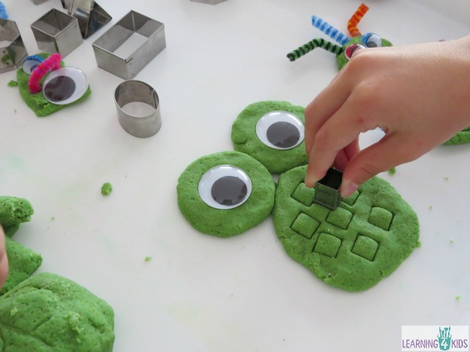

Learning Opportunities
- Fine Motor Development
- Hand-Eye Coordination and Control
- Overcoming challenges – problem solving
- Spatial awareness – experimenting with shape and space
- Language development – shape names, stories telling
- Mathematics – measurement
- Imagination – create stories
- Creativity

Edible Play Dough Recipe

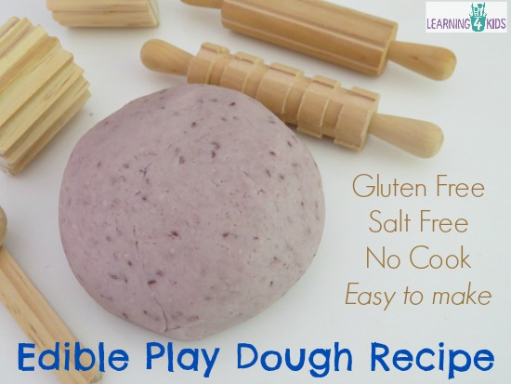
This Edible Play Dough Recipe for Babies, is a great ‘first time’ play dough for babies and toddlers.
It is super easy to make, contains no salt, is gluten free and is safe for babies, toddlers and older children who are more likely to place play dough into their mouths.
Babies and toddlers are naturally curious and explore the world around them using their senses and this sometimes means they place items into their mouths. When giving play dough to young children, we should try to discourage placing play dough into the mouth but if some does make it in, it is always nice to know that the play dough is homemade and safe for your child.
Edible Play Dough Recipe is the perfect alternative to traditional play dough recipes for babies 12months – 18 months and beyond.

What you will need?
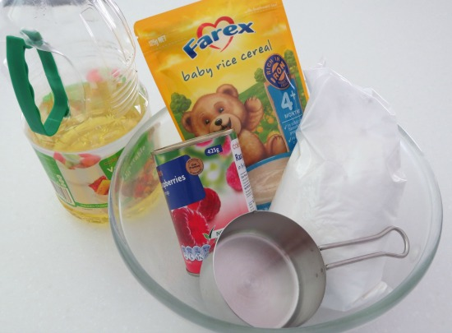

Ingredients
1 cup of Gluten Free Cornflour (cornstarch)
1 ½ cups of baby rice cereal
3 tbs vegetable oil
1/4 cup pureed tin of raspberries in syrup (or fruit puree of your choice)
1 Tbs water

How to make it?
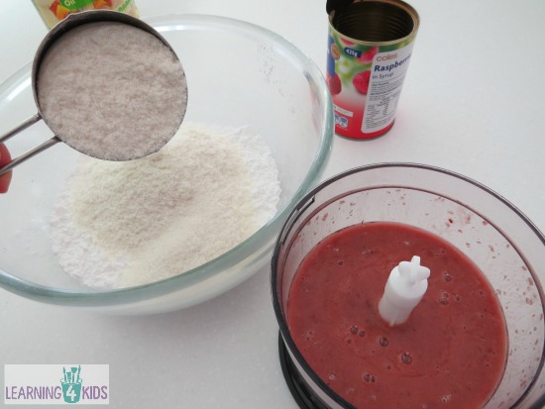
- Food process tinned raspberries in syrup until raspberries are pulped.
- Pour all dry ingredients, baby rice cereal and cornflour into a large bowl.
- Add 3tbs of vegetable oil and ½ cup raspberry puree/juice. Combine well with an electric mixer.
- If the mixture is sticky, slowly add more Baby Rice Cereal and mix well with electric mixer completely before adding more.
- If the mixture is dry, slowly add small amounts of water and mix until the dough is smooth and malleable.
- Turn mixture out onto the bench and knead by hand until the mixture is smooth.
- Store in a plastic zip lock bag or air tight container in the fridge. When removed from the fridge, kneading with warm hands will soften the play dough again.
- This play dough recipe does not include any preservative and will last several days in the refrigerator. The play dough life expectancy will depend on temperature, how long the play dough has been left out and how many children have played with the dough. Please always check the play dough for mould or unpleasant odours before giving it to children.

Let’s Play
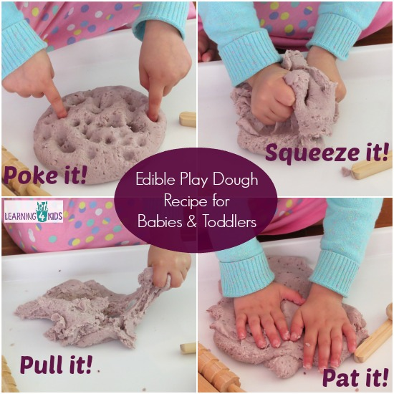
Play dough is a great tool to build and develop strength and control in the hands, fingers and wrists. This strength and control supports the use of writing tools, scissors and the ability to throw and catch objects. Playing with play dough and the repetitive moulding and manipulating really gives fine motor muscles a real work out!!
Encouraging babies and toddlers to manipulate play dough using repetitive words such as poke it, squeeze it, pull it, pat it and squish it is not only promoting fine motor coordination and strength but also oral language development.
Welcome and thank you for visiting Learning4kids. You will find lots of FUN and SIMPLE IDEAS to do with your kids that promote CREATIVE PLAY and LEARNING!

No Cook Sandy Play Dough Recipe

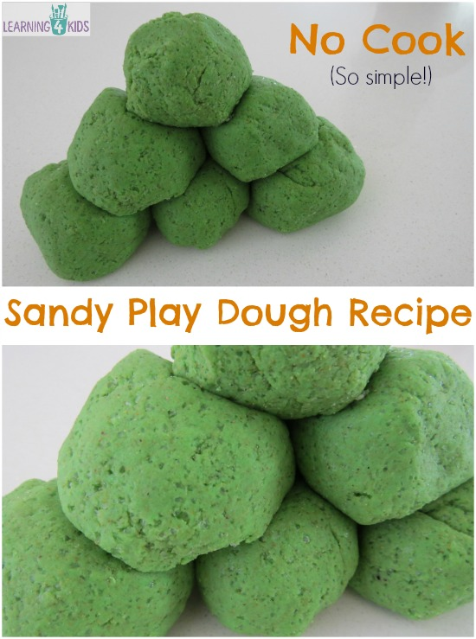
Looking for something a little different to standard play dough? Not that anything is wrong with standard play dough, we absolutely love it at our place but it is always nice to have something a little different, something textured to change things up a bit and keep sensory play dough experiences fun, interesting and motivating.
This Sandy Play Dough Recipe is flecked with colour and texture from the sand and children and they will enjoy the tactile experience.

What you will need?
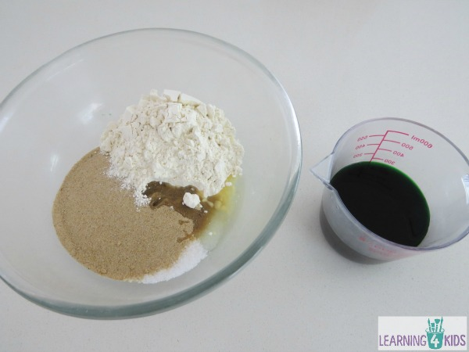
2 Cups Clean Sand
1 ½ Cups Flour
½ Cup Salt
2 Tablespoons Oil
1 Cup of water
Food Colouring (optional)

Method
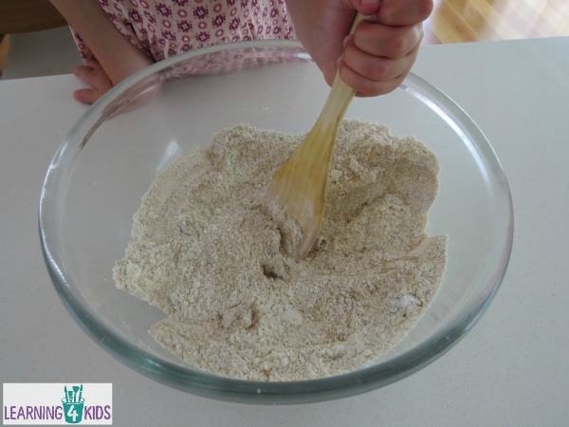
- Combine the sand, flour and oil into a large mixing bowl.
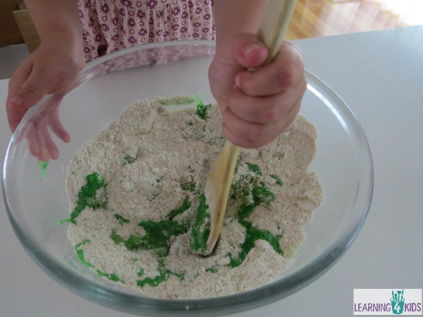
- Mix the water and food colouring together in a cup.
- Add the water gradually and knead with hands until the mixture forms a ball and a play dough consistency.
If the mixture is too dry, gradually add water until it reaches a nice consistency. If the mixture is too watery, gradually add more flour.
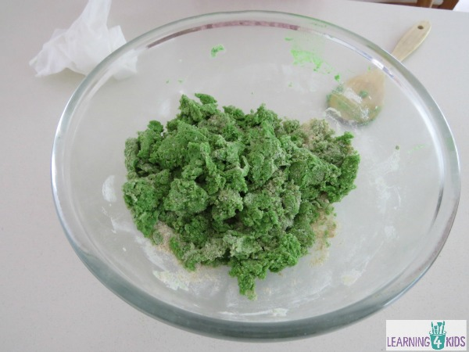
I love how the green has come out bright but the sand gives the play dough darker a fleck of texture. We plan to use our Green Sandy Play Dough to create Green Sandy Play Dough SHAPE MONSTERS. Take a look here!!

Microwave Play Dough Recipe
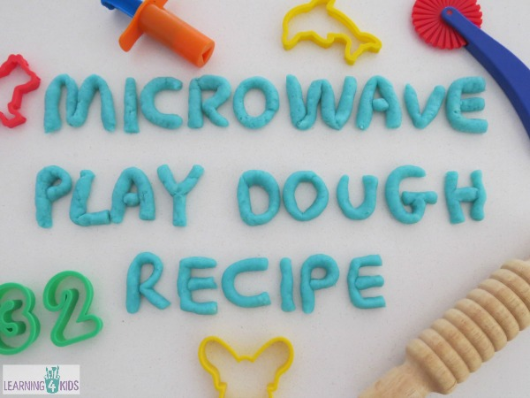
Microwave Play Dough Recipe is so easy to make at home and will provide hours of fun for kids of all ages.
This recipe has been altered from our basic play dough recipe and heated in the microwave instead of on the stove top.
Children will have hours of fun moulding, printing and shaping the play dough into creative and imaginative sculptures.

What you will need?
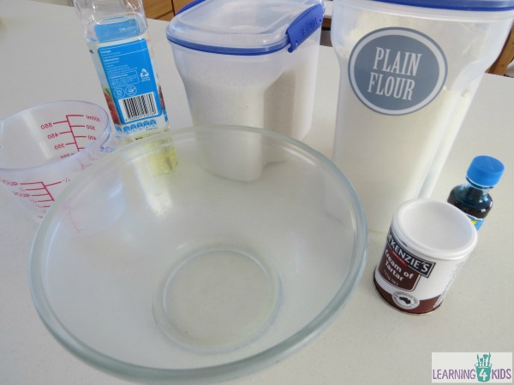
1 cup plain flour
1 tbsp. oil
1 cup water
½ cup salt
2 tbsp. cream of tartar
Food colouring
*Double the recipe for larger groups of children*

Method
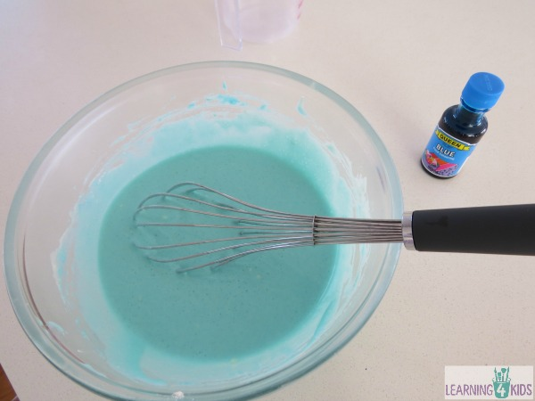
- Pour all dry ingredients, flour, salt and cream of tartar together into a microwave heat proof container, casserole dish or bowl.
- Add water and oil to dry ingredients. Add food colouring until desired colour is achieved.
- Mix together using a whisk to remove lumps and blend the ingredients well.
- Cover and place in the microwave for 2 minutes on high.
- Remove from microwave and stir with a wooden spoon.
- Place in the microwave for 1 min, remove and stir to combine. Cook for a further minute if the play dough is still runny.
- Then turn out onto a clean surface and knead into a smooth ball. Be careful the play dough will be very hot! Use a little bit of flour if the play dough is sticky.
- Allow the play dough to cool before playing with it.
- Store in a plastic zip lock bag or air tight container.
Please note: the microwave times mentioned may vary depending on different microwave types and settings.

